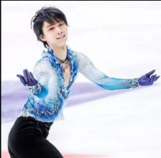

**THAT WHICH WHO**

**Who is the coolest student in your classroom?**

**Who can dance well in the classroom?**

**Which profession/job do you want to be in the future?**

**Which**

**country　do you want to visit?**

**What is a fukubukuro?**

Start

finish

Move ahead 4 spaces

Move back 5 spaces

**What is AI technology?**

**Which sport do you want to try?**

**What amusement park is the best for you?**

**Who is**

**Hanyu Yuzuru?**

**What is oshibori?**

**Which movie do you think is the most interesting?**

**Who is the coolest person in the world?**

**Who is Luffy?**

Relax!

**What do you think is the most expensive food?**

**What subject is the most difficult for you?**

**What thing is very important for you?**

Relax!

Move ahead 5 spaces

Go back to start!

**Which food do you want to try?**

**Who is the famous person you want to meet someday?**

**What do you want to do on Saturday?**