how to make omurice?  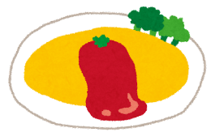  name: ____________ | how to play the guitar?  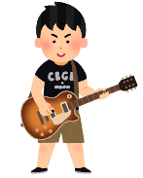  name: ____________ | what to eat to be healthy?  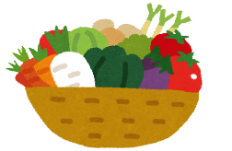  name: ____________
who to ask for help in Math class?  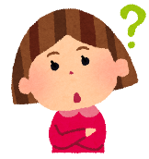  name: ____________ | where to see the Eiffel Tower?  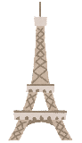  name: ____________ | what to wear in the rain?  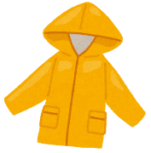  name: ____________
where to buy a Christmas Tree?  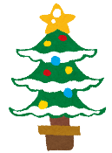  name: ____________  j | 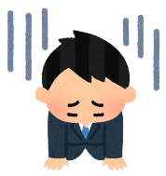  what to say when you're sorry?  name: ____________ | where to eat Italian food in Otsuka?  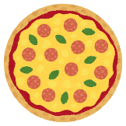  name: ____________
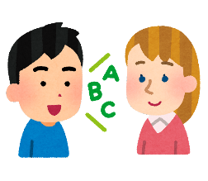  how to say “健康的” in English?  name: ____________  j | 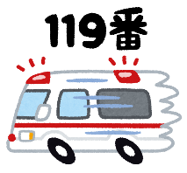  who to call in an emergency?  name: ____________  j | how to make sushi?  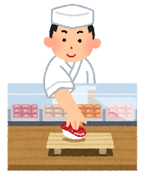  name: ____________  j
Do you know…
Yes, I do. I know…. / No, I don’t. I don’t know….
how to make omurice?  name: ____________ | how to play the guitar?  name: ____________ | what to eat to be healthy?  name: ____________
who to ask for help in Math class?  name: ____________ | where to see the Eiffel Tower?  name: ____________ | what to wear in the rain?  name: ____________
where to buy a Christmas Tree?  name: ____________  j | what to say when you're sorry?  name: ____________ | where to eat Italian food in Otsuka?  name: ____________
how to say “健康的” in English?  name: ____________  j | who to call in an emergency?  name: ____________  j | how to make sushi?  name: ____________  j
Do you know…
Yes, I do. I know…. / No, I don’t. I don’t know….
Yes, I do. I know…. / No, I don’t. I don’t know….
Yes, I do. I know…. / No, I don’t. I don’t know….

