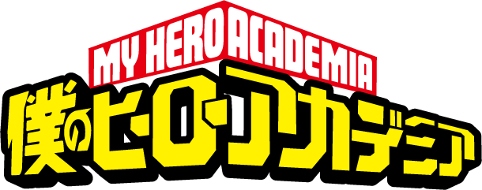
Name:___________________________Class:________Program Number:_____
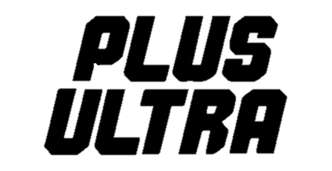

Write down the correct word in English. Correct word
and spelling = 1 point.
PHASE 1
___/18
Round 1

- ______________________ 2. ______________________ 3. ______________________

- ______________________ 5. ______________________ 6. ______________________
Round 2

- ______________________ 2. ______________________ 3. ______________________

- ______________________ 5. ______________________ 6. ______________________
Round 3

- ______________________ 2. ______________________ 3. ______________________

- ______________________ 5. ______________________ 6. ______________________

PHASE 2
___/18

Round 1

- ______________________ 2. ______________________ 3. ______________________

- ______________________ 5. ______________________ 6. ______________________
Round 2

- ______________________ 2. ______________________ 3. ______________________

- ______________________ 5. ______________________ 6. ______________________
Round 3

- ______________________ 2. ______________________ 3. ______________________

4. ______________________ 5. ______________________ 6. ______________________

PHASE 3
___/18

Round 1

- ______________________ 2. ______________________ 3. ______________________

4. ______________________ 5. ______________________ 6. ______________________

Round 2

- ______________________ 2. ______________________ 3. ______________________

4. ______________________ 5. ______________________ 6. ______________________

Round 3

- ______________________ 2. ______________________ 3. ______________________

4. ______________________ 5. ______________________ 6. ______________________
____/54
SCORE RESULTS: What is your total score?
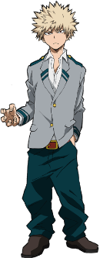
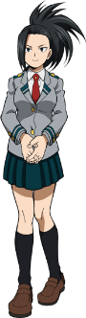
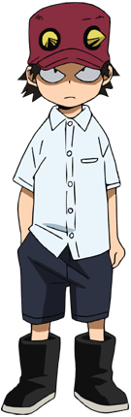
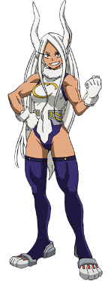
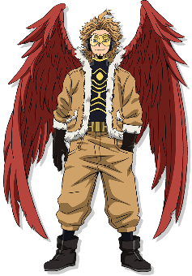
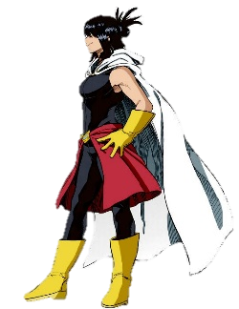
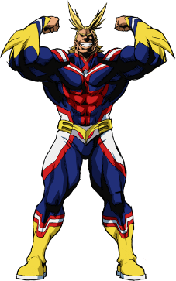

個性needs work
Hero in training
Pro Hero
Super Hero
0~12 points
13~26 points
27~40 points
41~54 points
Notes:

