Asleep/Awake
yesterday
was
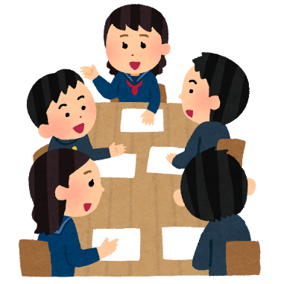
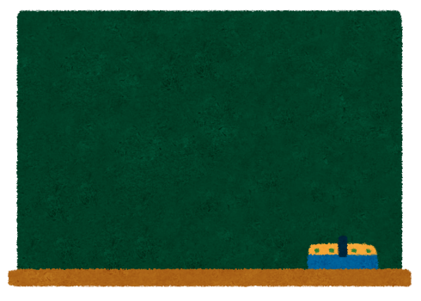
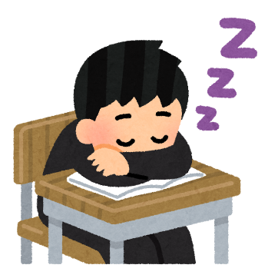
playing
I
was
soccer

-----------------------------------------------------------------------------------------------------------------------------------------------------------
My word is…

Round 1
_______________________________________________________________________________________________

My word is…

Round 2

_______________________________________________________________________________________________
My word is…

Round 3
_______________________________________________________________________________________________
My word is…

Round 4

_______________________________________________________________________________________________

Round 5
My word is…

_______________________________________________________________________________________________

My word is…

Round 6

_________

My word is…

Round 7

_______________________________________________________________________________________________
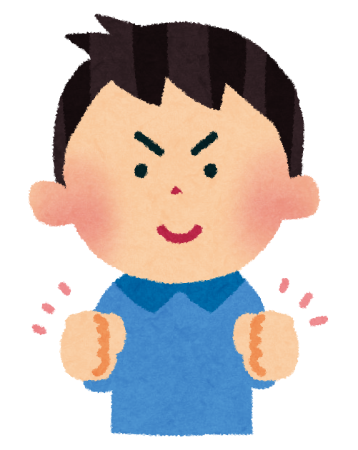

WELL DONE

