**Terry Fox Canadian Hero**

*Terry Fox Facts*

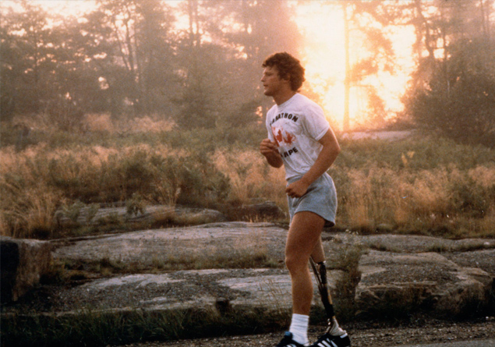 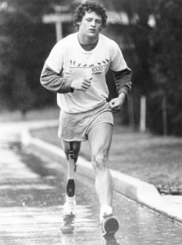

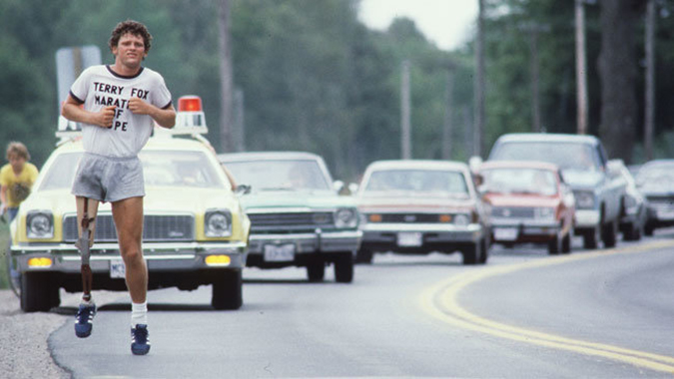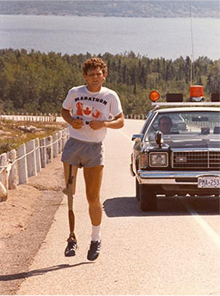

* In Canada students have Terry Fox run in September.
* Terry Fox’s birthday is July 28th 1958.
* Terry Fox liked basketball. He was in the basketball club.
* He ran in stormy and hot sunny days. He ran 42 km a day!
* He used 24 pairs of shoes.

**What would you run to change?** 



**Terry Fox**