Name:_____________________________

Unit 7: Welcome to Japan
例
Hello, everyone.
1. Welcome to Tochigi.
紹介する県
2. You can eat ramen in Sano City.
紹介するもの、場所、など
市
P.D p.18-19
3. It’s delicious.
P.D p.10か29
味、様子、など
You can see Kegon Falls in Nikko City.
紹介するもの、場所、など
P.D p.18-19
市
It’s beautiful.
P.D p.10か29
味、様子、など
Thank you for listening!
You can see – OOが見えるよ！
You can eat – OOを食べられるよ！
You can enjoy – OOを楽しめるよ！

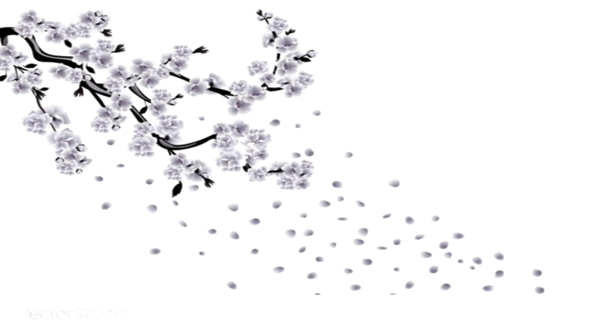
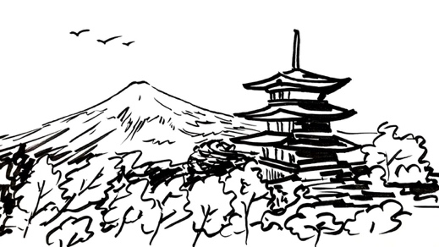
Welcome
to
Japan
Hello, everyone.
- Welcome to ⒏
- You can ⒑
⒑
- It’s ⒑

You can ⒑
⒑
It’s ⒑

Thank you for listening!

