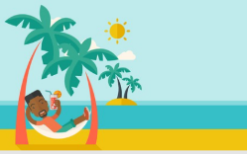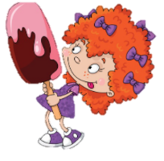

What do you do in

s mmer?



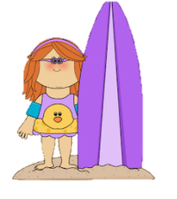

What do you do during the

summer vacation?

Friend’s name:_____________

I usually_______________________________________

____________________________________________

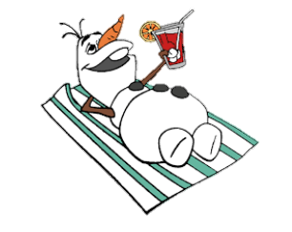

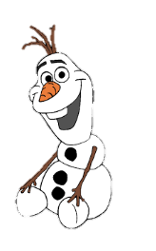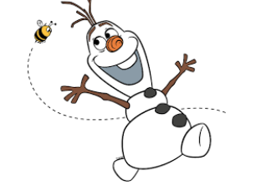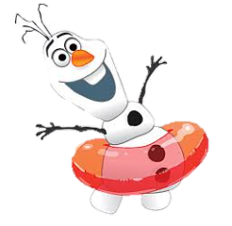

Name: ___________________No.____Class:________Date_________

Friend’s name:_____________

I usually_______________________________________

____________________________________________

Friend’s name:_____________

I usually_______________________________________

____________________________________________

Friend’s name:_____________

I usually_______________________________________

____________________________________________