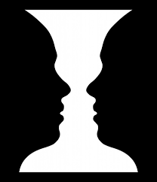
Optical Illusions
Example- Is it a vase or two people?
I think it is a vase.

- I think the cat is ( going up / going down ) the stairs.
- I think it is a ( rabbit / duck ).
- I think it is a ( rabbit / raven ).
- I think she is ( a young woman / an old woman ).
- I think it is _________ people.
- I think it is a ( frog / horse ).
- I think it is a ( man running / dog ).
- I think it is a ( lion / zebra ).
- I think it has _________ legs.
- I think it is a ( man / dog ).
- I think it is going ( left / right ).
- I think it is ( a face / someone walking )
- I think they have (the same / different ) length.
- I think she is turning ( right / left )
- I think the image is ( disappearing / not disappearing )
- I think the dots are ( disappearing / not disappearing )
- I think it is __________________.

Useful phrases:
- I agree with you.
- I don’t agree with you.
- Wow! That’s crazy!
- Interesting!

