Total Eclipse of the Sun-皆既日食
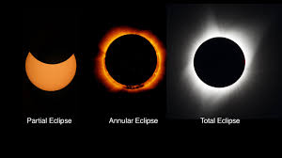
Pilots have chased-追われた a total eclipse of the sun. People in North America looked at this rare-稀 event. NASA sent planes with special sensors-センサー to learn about the sun. Pilots flew 15,240 meters high to get a view of the corona – the sun's outer surface-外面.
A total solar eclipse blocks-塞ぐ the sun, and looks like it turns day to night. Totality means the sun's corona is dark. NASA explained that: "Total solar eclipses let us study-研究 the sun in ways that we can`t at any other time." Solar eclipses confuse-混同 animals. They wake up night animals, and make birds quiet..
