2nd MATCH
Name: _________________ Class: ______ Number: ____

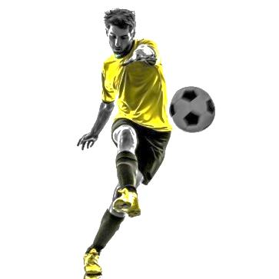
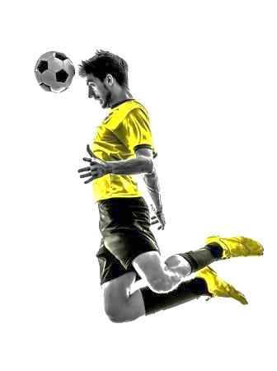
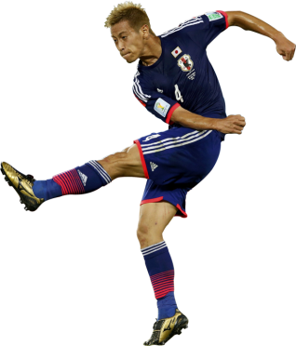
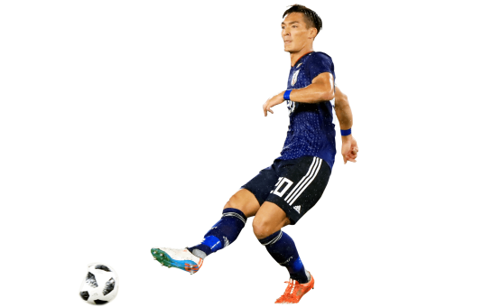
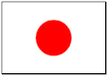
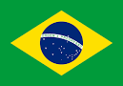
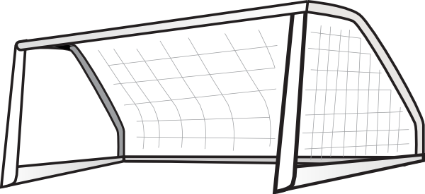
~ is a good show watched on ~
~ is a fun game played at/on~
~ is a cool song sung by ~
~ are useful tools used by/at~
Brazil Goals

Japan Goals

Writing Practice
- ___________________________________________________
- ___________________________________________________
- ___________________________________________________
- ___________________________________________________
- ___________________________________________________
Goal!!!
Goal!!!

- Who is Mark?
- (I saw a _______. It was made in ________.)
- Who are Ken and Bill?
- (______ is a song. It was sung by ________.)
- Who is Alice?
- (I like many _______. They were written by ________.)
- Who is Yoko?
- ( _______ is a delicious dish. It is eaten in ________.)
- Who is Hiroshi?
- ( _______ are dangerous animals. They are seen in ________.)
- Who are Mary and Linda?
- ( _______ is a heavy item. It is used at ________.)
- Who is Tod?
- ( ______ is a place. It is visited on _____.)

Name: ___________ Class: ___ Number: ___ Date: ___/___

- _______________________________________________________________
_______________________________________________________________
- _______________________________________________________________
_______________________________________________________________
- _______________________________________________________________
_______________________________________________________________
- _______________________________________________________________
_______________________________________________________________
- _______________________________________________________________
_______________________________________________________________
- _______________________________________________________________
_______________________________________________________________
- _______________________________________________________________
_______________________________________________________________
- _______________________________________________________________
_______________________________________________________________
- _______________________________________________________________
_______________________________________________________________
- _______________________________________________________________
_______________________________________________________________
- _______________________________________________________________
_______________________________________________________________
- _______________________________________________________________
_______________________________________________________________
- _______________________________________________________________
_______________________________________________________________
- _______________________________________________________________
_______________________________________________________________

1st MATCH
Name: _________________ Class: ______ Number: ____

~ is a tasty food eaten in ~ / by ~
~ is a nice place visited in ~
~ is a fun sport played in ~ / by ~
~ are cool animals seen in ~
Brazil Goals

Japan Goals

Writing Practice
- ___________________________________________________
- ___________________________________________________
- ___________________________________________________
- ___________________________________________________
- ___________________________________________________
Goal!!!
Goal!!!

