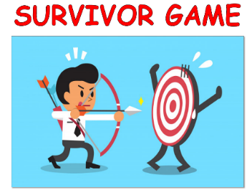
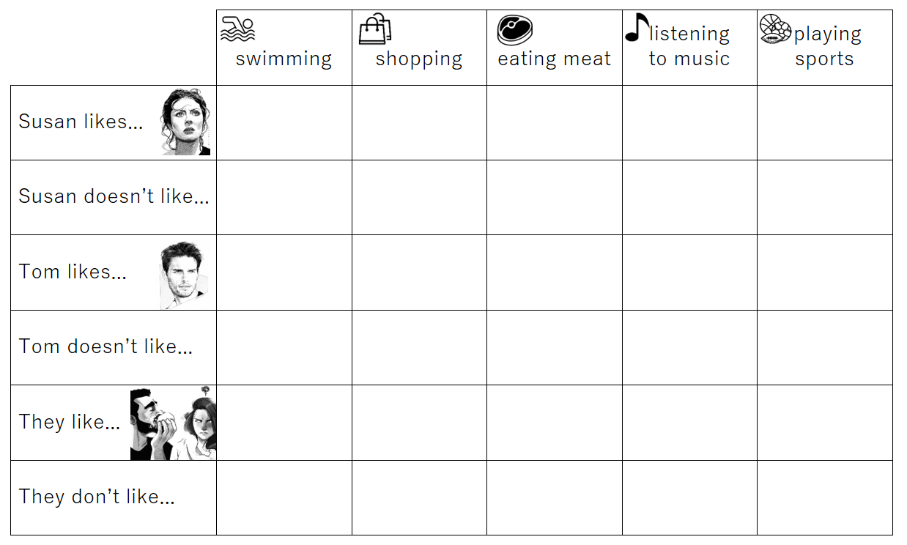
Name: ____________ Class: ______ Number: _______ Date: ___/___

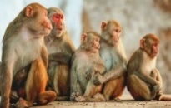
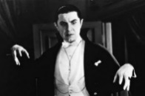
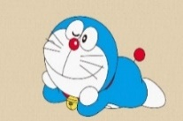
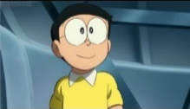
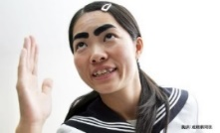

- __________ likes playing ___________. She thinks _________ it is ___________.
- ________ like eating ____________. They think eating ________ is _____________.
- _________ _____ listening to __________. She thinks listening to her is __________.
- _________ doesn’t _____ meeting a ________. He thinks ______ one is _________.
- __________ like _______ ____________. They think watching it is ____________.
- __________ ____ like eating __________. They think ____ it ____ _____________.
- ______ _____ ____ taking _________. He thinks ______ them is _____________.
- __________ _____ drinking _____________. She thinks drinking it is ____________.
What do you like doing in your free time?
___________________________________________________________________
___________________________________________________________________
___________________________________________________________________
What do you not like doing?
___________________________________________________________________
___________________________________________________________________
___________________________________________________________________

