The Christmas Scene!
PART 1

Hints
- Kate is sitting under a tree.  - Ken is wearing a ski gear.  - Mr. Oda is using a snowblower.  - Anna is slipping(滑り).  - Tom is sledding down the mountain.  - Emi is with Tom. | - Yamato is in a car.  - Max has a fish.  - Harry is going to school.  - Yuki is with Harry.  - Shingen is fighting a Yeti(雪男)!  - Maru is bicycling.
Kate:____ Max:____ Mr. Oda:____ Anna:____ Tom:____ Emi:____ Yamato:____ Jen:____ Yuki:____ Harry:____ Shingen:____ Maru:____

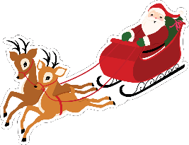
PART 2

Please write the question or the answer. 質問か答えを書いてください。
例 Q1. Who is Kate? 例A1. She is the girl who is sitting under the tree.
例 Q2. Who is the boy wearing ski gear? 例A2. He’s Ken.
Q1. Who is Mr. Oda? A1. He’s the man ___________________________________.
Q2. Who is Anna? A2. She’s ________________________________________.
Q3. Who are ___________ and ___________? A3. They’re the children that are sledding
Q4. Who is the man in the car? A4. He’s _______________.
Q5. Who is _______________? A5. He’s the man who is holding the fish.
Q6. Who are the children going to school? A6. They’re _______ and _______.
Q7. Who is _________________________________________? A7. He’s Shingen.
Q8. Who is the reindeer(トナカイ) bicycling? A8. She’s _______________.

