The best food in Japan!
My top three Japanese dishes:
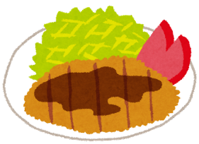
例: tonkatsu

- I think is a good Japanese dish.

- But I like better.

- But overall, I like the best because .
Interview your classmates.

Q: What Japanese dish do you like the best?
A: I like ~~~ the best.

Name of Japanese dish

In my class, is the best Japanese dish.

