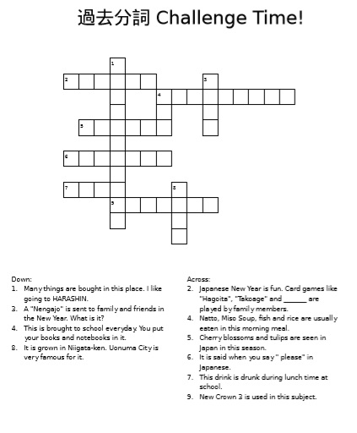

Answer Key
Down:
1. supermarket
3. card
4. bag
8. rice
Across:
2. Karuta
4. breakfast
5. spring
6. kudasai
7. milk
9. English

