Name: _____________________ Class: ___ Number: ____

1. Who is the fastest writer? Write the word 9 times.
beautiful

Winner: ___________________________

2. Who is the fastest speaker?
Speak this sentence 5 times fast.
‘A big black bug bit a big black bear’
Me: __________ seconds (How fast are you?)
Winner: _________________________________
3. Whose picture is the nicest?
4. Who is faster? Read this sentence 5 times aloud.
“A big black bug bit a big black bear.”

You (______ seconds) Friend (_______seconds)

Winner:______________________________
4. Who is faster? Read this sentence 5 times aloud.
“A big black bug bit a big black bear.”

You (______ seconds) Friend (_______seconds)

Winner:______________________________
4. Who is faster? Read this sentence 5 times aloud.
“A big black bug bit a big black bear.”

You (______ seconds) Friend (_______seconds)

Winner:______________________________
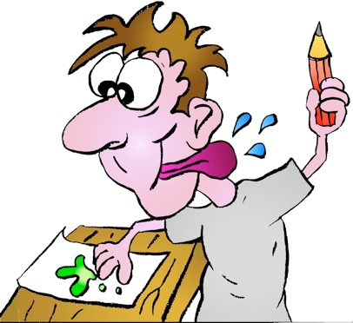
Winner: _______________________
Total: __________
1. _________________________________________
2. _________________________________________
3. _________________________________________
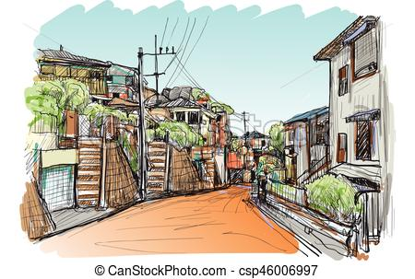
Our School and Our Town
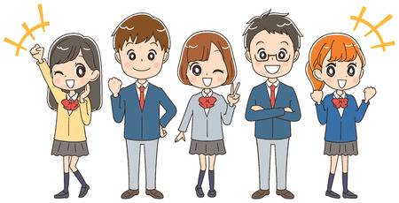

例: tall
Mt. Hakai is the tallest mountain in Minamiuonuma.
It is very beautiful in the autumn.
You can ski there.
Pick a word
big | long | cool | smart | hot | heavy | busy
small | short | nice | strong | cold | light | quiet

- _______________________________________________________________
_______________________________________________________________
_______________________________________________________________
- _______________________________________________________________
_______________________________________________________________
_______________________________________________________________
- _______________________________________________________________
_______________________________________________________________
_______________________________________________________________
- _______________________________________________________________
_______________________________________________________________
_______________________________________________________________

