What would you like for breakfast?
Name: _______________
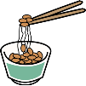
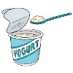
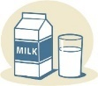
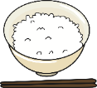
- Would you like some rice? Would you like some bread?
- How about some tea? How about some milk?
- Would you like a banana? Would you like a yogurt?
- How about some natto? How about some eggs?

Yes, please. (1 point) No, thank you. (0 points)
Name: _________
Points: ________
Total: _______
Name: _________
Points: ________
Name: _________
Points: ________
Name: _________
Points: ________
Name: _________
Points: ________

Name: _________
Points: ________

I’m hot and hungry.
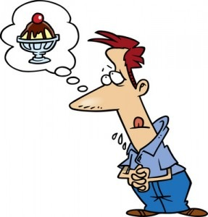
Would you like some ice cream? It’s sweet and cold.
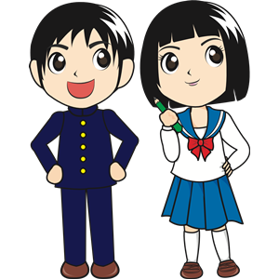
Thanks! That sounds great. Now I’m…

- ________________________________________________________
________________________________________________________
- ________________________________________________________
________________________________________________________
- ________________________________________________________
________________________________________________________
- ________________________________________________________
________________________________________________________
- ________________________________________________________
________________________________________________________
- ________________________________________________________
________________________________________________________
- ________________________________________________________
________________________________________________________
- ________________________________________________________
________________________________________________________
- ________________________________________________________
________________________________________________________
- ______________________________________________________
________________________________________________________
- ________________________________________________________
________________________________________________________
- ______________________________________________________
_________________________________________________________

- I’m tired but I can’t sleep at school.
- I’m hungry. I want to eat something new.
- I’m sad. My dog died.
- I’m scared. I saw a ghost in my room.
- I’m angry. I had a fight with my friend.
- I’m cold. I have to be outside for a long time.
- It’s raining today and I have to go running.
- It’s Christmas. I want a nice present.
- I have a Japanese test. I want to study.
- My car is broken. I don’t have any money.
- I’m hot. I want something to drink.
- I’m interested in Japan. I want something from Japan.

