Name: ______________________

**Strange Pirates**

#1

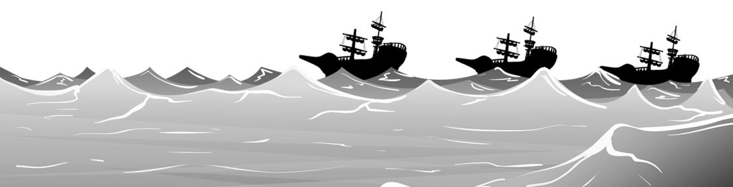

Will it be ~ tomorrow?

snowy

rainy

sunny

Sign:

Sign:

Sign:

Sign:



#2

Will it be ~ ____________?

cold

cool

warm

Sign:

Sign:

Sign:

Sign:



#3

warm and cloudy

cold and snowy

Hot and sunny

Will it be ~ ____________?

Sign:

Sign:

Sign:

Sign:

1. _________________________________________________________________
2. _________________________________________________________________
3. _________________________________________________________________