If... | Option 1 | Option 2 | Option 3
If you have time, what will you do? | 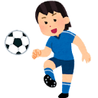  If I have time, I will play... | 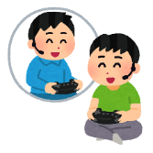  If I have time, I will play... | 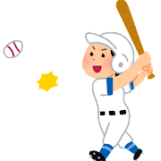  If I have time, I will play...
If you go to Australia, what will you do? | 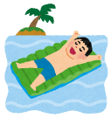  If I go to Australia, I will go to the... | 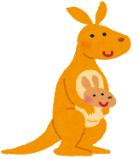  If I go to Australia, I will see a... | 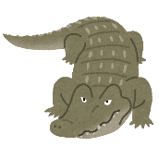  If I go to Australia, I will see a...
If you cook dinner tonight, what will you cook? | 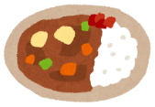  If I cook dinner tonight, I will cook... | If I cook dinner tonight, I will cook... | 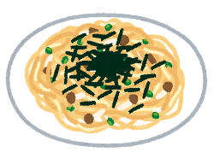  If I cook dinner tonight, I will cook...
If you go to McDonald’s, what will you buy? | If I go to McDonald’s, I will buy... | 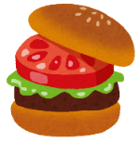  If I go to McDonald’s,  I will buy a... | 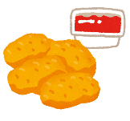  If I go to McDonald’s,  I will buy...
If you feel sick, where will you go? | If I feel sick, I will go... | If I feel sick, I will go to the... | If I feel sick, I will go to the...

‘IF’ TOTAL TABLE BINGO!
- Janken with a partner. Winner asks a question. Then, loser will ask a question.
- The one who answered the question will sign their name on their partner’s sheet.
- The GOAL is to get all answers. GOOD LUCK!

WRITING PRACTICE – KEY SENTENCE PAGE 24
If you have time, we can go.
We can go if you have time.

Write the sentences from the table, or make your own!
Example: If I feel sick, I will go home. (I will go home if I feel sick.)
- ____________________________________________________________________________________________________________________________________________
- ____________________________________________________________________________________________________________________________________________
- ____________________________________________________________________________________________________________________________________________
- ____________________________________________________________________________________________________________________________________________
- ____________________________________________________________________________________________________________________________________________
- ____________________________________________________________________________________________________________________________________________
- ____________________________________________________________________________________________________________________________________________
- ____________________________________________________________________________________________________________________________________________

