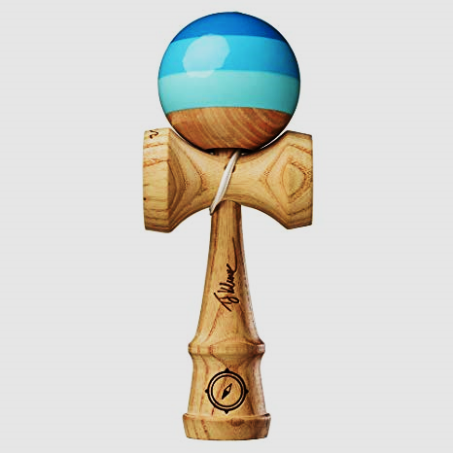
FILL IN THE BLANKS
Name: ________________ Class: ____ Number: _____
例: ______ is a toy which has a ____ and ______.
- _______ is a city which has many __________.
- _______ is a dog who _______ on his house.
- _______ is a child who doesn’t like _________.
- _______ is a sport which uses a _____ and _______.
- _______ is a boy ____ plays _________.
- ________ is a TV show ____ is seen on _______.
- ________ are animals ______ eat ________.
- ________ are people ______ stop ________.
- ________ is a city ____ has delicious _______.
- ________ is a cat _____ is ____ _____ tall.
- ________ is a sport ______ uses a small ______.
- ________ is a town ______ has _______ ________.
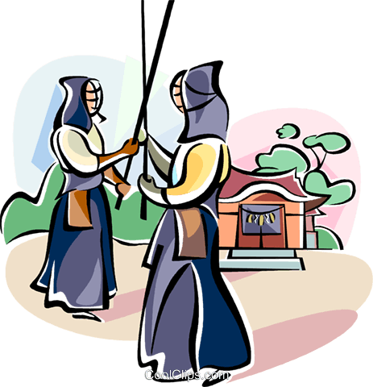
HELLO KITTY GAME
We call this sport ________.
It is a _______ ____ _________________________________
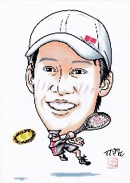
__________________________________________________
We call this man ___________.
He is a _______ ____ _________________________________
__________________________________________________
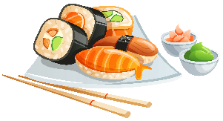
We call this dish _________.
It is a _______ ____ _________________________________
__________________________________________________
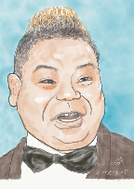
We call this man ____________.
He is a _______ _____ _________________________________
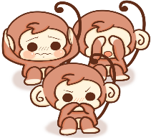
__________________________________________________
We call these animals _________.
They are _______ ____ _________________________________
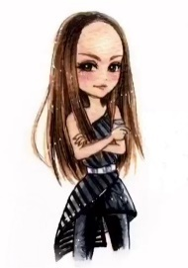
__________________________________________________
We call this woman __________.
She is a _______ ____ _________________________________
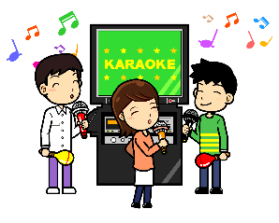
__________________________________________________
We call this activity __________.
It is an _______ ____ _________________________________
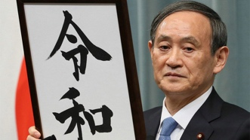
__________________________________________________
We call this man __________.
He is a _______ ____ _________________________________
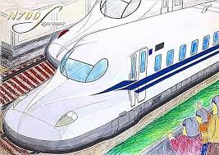
__________________________________________________
We call these trains ____________.
They are _______ ____ _______________________________
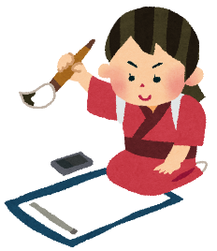
__________________________________________________
We call this art _______.
It is an _______ _____ _______________________________
__________________________________________________

