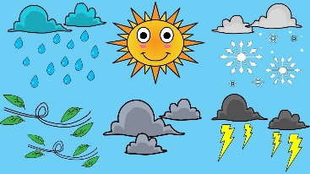
Name: ______________________ Class: ___ Number: ___ Date: ___ /__
How will the weather be on Monday?
It will be hot and sunny.

ROUND ONE

START
GOAL
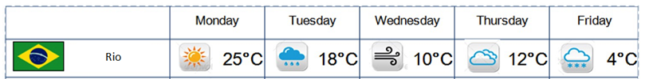
GOAL

ROUND TWO

START

- If it’s _______, ________________________________________________________________________
- If it’s _______, ________________________________________________________________________
- If we have __________, _________________________________________________________________
- If we go to _________, __________________________________________________________________
- If we ____ our ______, _________________________________________________________________
- If we have __________, _________________________________________________________________
- If we ___ many _______, ________________________________________________________________
- If we have ________ ___, _______________________________________________________________
- If it is ___________, ___________________________________________________________________
- If it is __________, __________________________________________________________________
- If we go to ________, ___________________________________________________________________
- If our _____ is ______, _______________________________________________________________
What will you do this weekend?
____________________________________________________________________________________
____________________________________________________________________________________
____________________________________________________________________________________

- What will you do if it’s sunny?
- What will you do if it’s rainy?
- What will you do if you have free time?
- What will you do if you go to Tokyo?
- What will you do if you meet your friends?
- What will you do if you have a test?
- What will you do if you eat many rice balls?
- What will you do if you have 10,000 yen?
- What will you do if it is snowy?
- What will you do if it is hot?
- What will you do if you go to Disneyland?
- What will you do if your teacher is angry?

