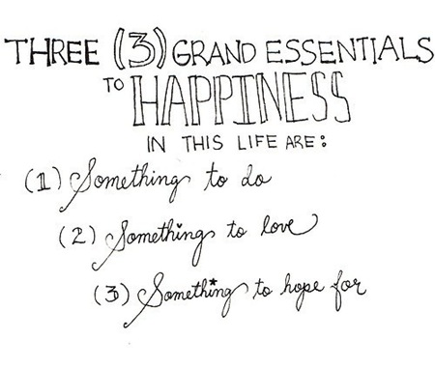
Name: _______________ Class: ___ Number: ___ Date: __/___

-Alan Chalmers

- __________ is someone to ____ ______ with.
- ____________ ___ something __ ____ in Italy.
- ________ ___ someplace ___ ___on ____ ____’s day.
- ______ ___ something __ ___ on _______ on ______.
- ________ ____ __________ to ______in Australia.
- ________ ____ ________ ___ ______in English class.
- ________ ___ _____to buy for ____ ______ ______.
- _________ ___ ________ to _____ in the _________.
- ________ ___ ______ ___ say at ___ in the _______.
- _______ ____ ________ ____ ____ ____ _________
- ___________________________________________
Because ____________________________________
- __________________________________________ Because ____________________________________
Hint One: _____________________________________
Hint Two: _____________________________________
Hint Three: ____________________________________
QUESTION: ______________
ANSWER: ________________

Hint One: _____________________________________
Hint Two: _____________________________________
Hint Three: ____________________________________
QUESTION: ______________
ANSWER: ________________

Hint One: _____________________________________
Hint Two: _____________________________________
Hint Three: ____________________________________
QUESTION: ______________
ANSWER: ________________
1. Who is someone to play tennis with?

2. What is something to eat in Italy?

3. Where is someplace to go on New Year’s Day?

4. What is something to watch on TV on Sunday?

5. What is something to see in Australia?

6. What is something to use in English Class?

7. What is something to buy for your mother’s birthday?

8. What is something to drink in the summer?

9. What is something to say at school in the morning?

10. Who is someone to meet in America?

11. What is something to see in Uonuma?

12. Where is someplace to visit in Uonuma?

