Name: _______________________________



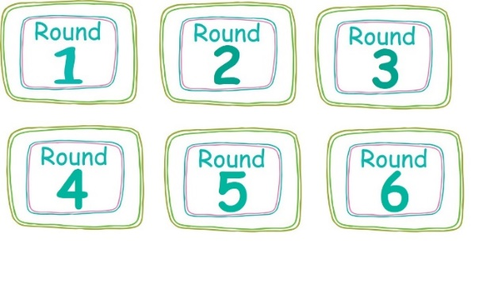A B C D E F G H I J K L M N O P Q R S T U V W X Y Z



                  
                  
                  
                  
                  
                  