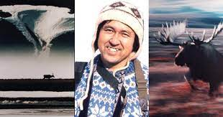
Pictures and Our Beautiful Planet
Name: _______________________
Page 123

1. Michiyo lived among the Inuit in Shishmaref for one summer?
When is summer in Shishmaref?
a) August, September, October b) December, January February
c) June, July, August d) September, October, November

2. What did Michiyo learn in Shishmaref?
a) How to shop at convenience stores in Alaska
b) How to take pictures of nature
c) about the Inuit peoples’ daily lives
d) about how to live a convenient life

3. The Inuit people get their food from nature. True False

4. The Inuit people live harmoniously with nature. Choose the best sentence.
a) They grow vegetables in hot houses in winter.
b) They order food on-line in the winter.
c) They only catch enough food to live. They don’t catch too much.
d) They hunt many animals and sell them.

5. Alaska is a small country near Canada. True False

6. How do you spell 便利なこと（もの）in English? ______________________________
7. What did Michiyo understand?
a) It’s hard to live in Shishmaref in winter.
b) Living in Shishmaref is not convenient.
c) All living things share the Earth.
d) Humans must use nature to survive.

8. Do you want to live in the wilderness in the future?

____________________________________________________________________________x

