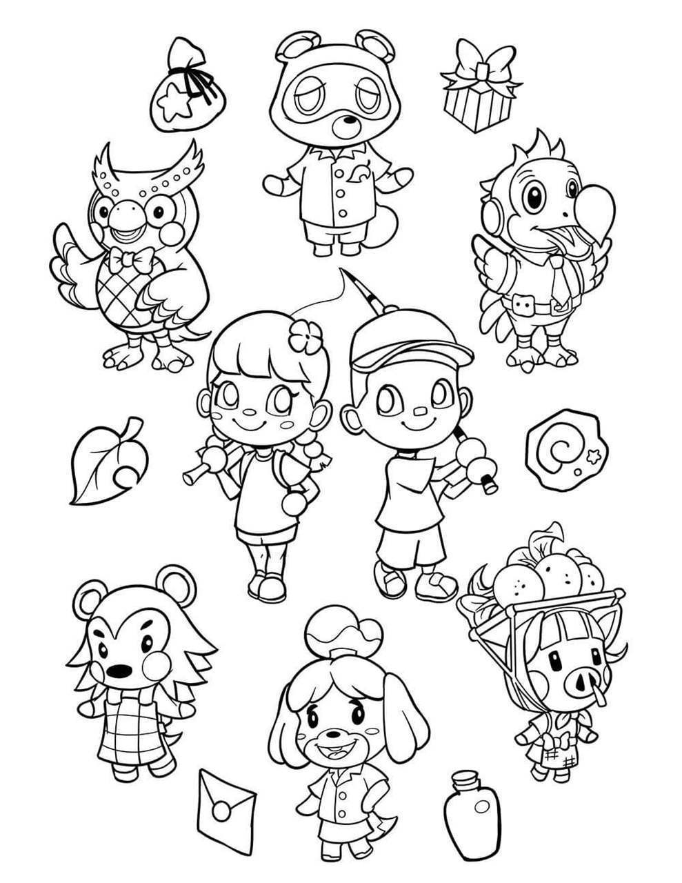p

Name: __________________ Class: _____-_____

___________________________________________________________________________

___________________________________________________________________________

___________________________________________________________________________

___________________________________________________________________________

___________________________________________________________________________

_________________________________________________________________________

__________________________________________________________________________

____________________________________________________  
  
  
_______________________________________________________  
  
  
____________________________________________________________

友達が遊びに来る前にする必要があることとないことを、「have to～」と「don’t have to～」を使って書きましょう。