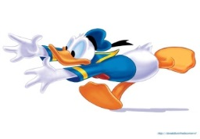
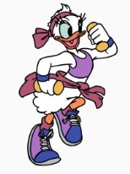
Name: ___________ Class: _____ Number: ______
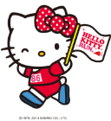
CHARACTER RACE

- FIND THE MISTAKES
- swiming ______________
- spagetti ______________
- strawberrie ______________
- umbrela ______________
- FILL IN THE BLANKS
- Hello, I __ Tanaka Kumi ____________________________
- Nice __ meet you. ____________________________
- Are you ____ Australia? ____________________________
- You __ welcome ____________________________
- CORRECT THE ORDER
- too/meet/to/you/nice/. ____________________________
- Canberra/from/I’m ____________________________
- not/I’m/No/hot/I’m/./././but/tired ____________________________
- Hokkaido/from/it/is/. ____________________________
- INTRODUCE YOURSELF
I’m _____________________________
I’m _____________________________
I’m not __________________________
I’m not __________________________
- FIND THE MISTAKES
- I is not hungry. __________________________
- Are you sleepy? No, I am. __________________________
- The is a fox. __________________________
- It is a old calender. __________________________

- FILL IN THE BLANKS
- What __ this? ___________________________
- She is good __ kendo. ___________________________
- He is a math _________. ___________________________
- Is she _____ friend? ___________________________
- CORRECT THE ORDER
- an/it/old/coin/is/. ___________________________
- he/PE/a/is/teacher/? ___________________________
- good/is/he/at/basketball/. ___________________________
- friend/my/Kumi/is ___________________________
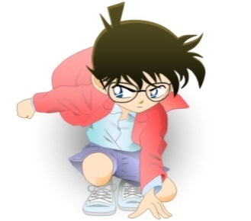
- INTRODUCE THIS CHARACTER
________________________________
________________________________
________________________________
________________________________
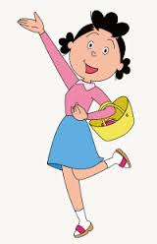
- INTRODUCE THIS CHARACTER
________________________________
________________________________
________________________________
________________________________
- ASK FOUR QUESTIONS
_____________________________ Yes, I am.
_____________________________ Yes, I am.
_____________________________ Yes, she is.
_____________________________ Yes, he is.
11.
TALK TIME
12..
TALK TIME

