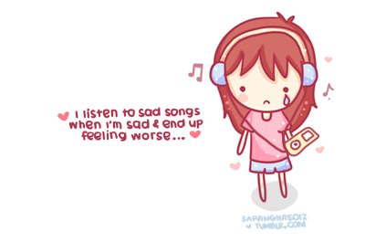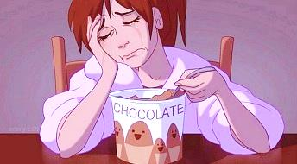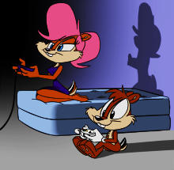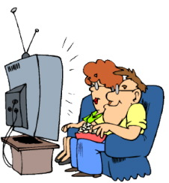

Ah, that’s nice.

Ah, that’s nice.

Oh really. I ____

Oh really? I ___

If I have free time, I __________.

If I am sad, I _____________.

Oh cool. Me too.

Sign Please

eat ice cream

#2

listen to music

play games

watch TV

Oh cool. Me too.

#1

**Let’s be friends forever!!!!**

Name: ____________________