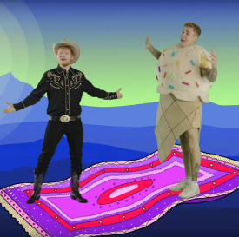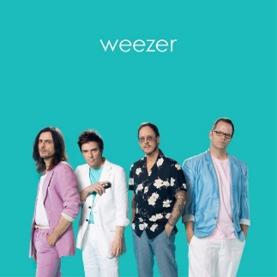

**MUSIC QUIZ – It’s hard! Yeah!**

①　Journey – Don’t Stop Believing

Working hard to get my fill  
Everybody wants a thrill  
Payin' anything to roll the dice  
Just (① 　 )(② 　　 )(③ 　　 )　　　　Some will win, some will lose  
Some were born to sing the blues  
Oh, the movie (④　 　　)(⑤　 　　)  
It goes on and on and on and on

⑤ Justin Bieber & Ed Sheeran – I Don’t Care

‘Cause I don’t care (①　 　　) I‘m with my baby, yeah  
All the bad things disappear  
And you’re (②　 　　) me feel like

maybe I am somebody  
I (③　 　　) deal with the bad nights  
(①　 　　) I'm with my baby, yeah  
Ooh, ooh, ooh, ooh, ooh, ooh  
'Cause I don't care as long as you just hold me near  
You can take me anywhere  
And you're (②　 　　) me feel like

I'm loved by somebody  
I (③　 　　) deal with the bad nights  
(①　 　　) I'm with my baby, yeah  
Ooh, ooh, ooh, ooh, ooh, ooh

④ Weezer – Pork and Beans

Everyone likes to dance to a happy (①　 　　)  
With a catchy chorus and beat so they can(②　 　) along  
Timbaland knows the way to reach the top of the charts  
Maybe if I work with him, I can (④　 　) the (③　 　　)

I'mma do the things that I wanna do

② Vanessa Carlton – A Thousand Miles

And I need you

And I miss you

And now I wonder

1. ) I could fall into the sky

Do you (②　 　　) time would pass me by

Cause you know I’d (③　 　　) a thousand miles

1. ) I could just see you, tonight

**PLEASE USE:**

art / can / ends / if / making / more / never / one / perfect / sing / song / think / time / when

[](https://www.google.com/url?sa=i&url=https%3A%2F%2Fwww.irasutoya.com%2F2018%2F11%2Fblog-post_516.html&psig=AOvVaw2hsOL0sNT_lT0wrF6yTRWX&ust=1608946220137000&source=images&cd=vfe&ved=0CAIQjRxqFwoTCKDo-fL95-0CFQAAAAAdAAAAABAD)[](https://www.google.com/url?sa=i&url=https%3A%2F%2Fwww.irasutoya.com%2F2014%2F05%2Fblog-post_2203.html&psig=AOvVaw1ndItIvkdjX-XPkSBZW_nM&ust=1608946182931000&source=images&cd=vfe&ved=0CAIQjRxqFwoTCLC9geL95-0CFQAAAAAdAAAAABAD)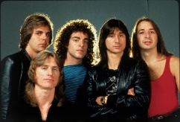**Level up in today’s music quiz! Enjoy listening to the songs and fill in the blanks!**

Name ( ) Class ( ) No ( )