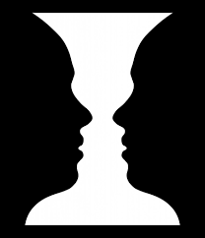
Optical Illusions
Example- Is it a vase or two people?
I think it is a vase.

- Is the cat going up or going down the stairs?
I think the cat is _________ the stairs.
- What animal is it?
I think it is a _________.
- Is it a rabbit or a raven?
I think it is a _________.
- Is she a young woman or an old woman?
I think she is ________________ .
- Is it two or three people?
I think it is _________ people.
- What animal is it?
I think it is a _________.
- Is it a man running or a dog?
I think it is a __________________.
- What animal is it?
I think it is a _________.
- How many legs does the elephant have?
I think it has _________ legs.
- Is it a man or a dog?
I think it is a _________.
- Is the bus going left or right?
I think it is going _________.
- Is it a face or someone walking?
I think it is __________________.
- Do the lines have the same or different length?
I think they have __________________ length.
- Is the ballerina turning right or left?
I think she is turning _________.
- Is the image disappearing or not disappearing?
I think the image is __________________.
- Are the dots disappearing or not disappearing?
I think the dots are __________________.
- What color is the dress?
I think it is __________________.

Useful phrases:
- I agree with you.
- I don’t agree with you.
- Wow! That’s crazy!
- Interesting!

