Name: _________________ Class: ______ Number: ____

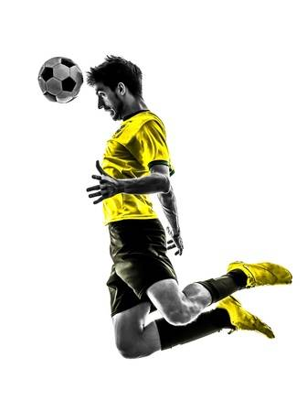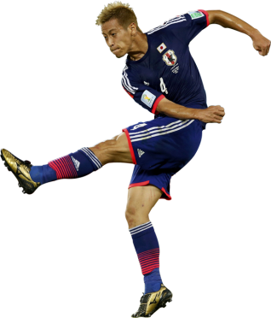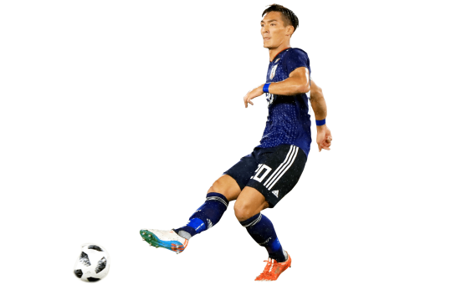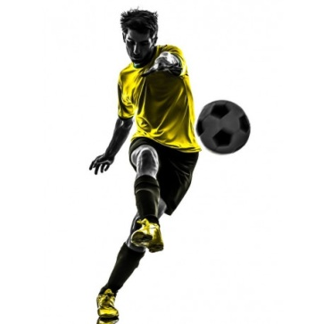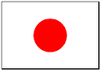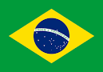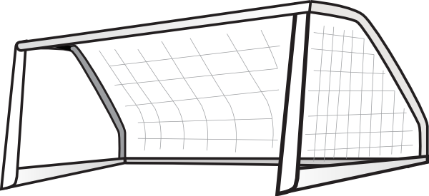

Brazil Goals

Japan Goals

Writing Practice

1. ___________________________________________________
2. ___________________________________________________
3. ___________________________________________________
4. ___________________________________________________
5. ___________________________________________________

*Goal!!!*

*Goal!!!*

Do you like~?

動物

Do you like~?

食べ物

Do you like~?

色

Do you like~?

教科