Dice Roll
Small Talk Warm-up
Questions and Answers
(Editing Page Below)
- Yes/No Questions
  - Do you like ~?
○Yes, I do. ×No, I don’t.
  - Can you ~?
○Yes, I can. ×No, I can’t.
  - Are you good at ~?
○Yes, I am. ×No, I’m not.
  - Do you usually ~?
○Yes, I do. ×No, I don’t.
  - Do you have brothers or sisters?
○Yes, I do. ×No, I don’t.
  - Was the game exciting?
○Yes, it was. ×No, it wasn’t.
*Bonus. Do you have a pen?
○Yes, I do. ×No, I don’t.
- 自己紹介など
  - What ～ do you like?
I like ～
  - What’s your favorite ～?
My favorite ～ is ____.
  - What are you good at?
I’m good at ～.
  - What can you do?
I can ～ (well).
  - Where do you want to go?
I want to go to ～.
  - What do you want to study?
I want to study ～.
*Bonus. Who is your hero?
My hero is my father. He can swim fast.
- Habits 習慣など
  - What do you usually do on Sundays?
I usually clean my room.
  - What time do you go to bed?
I go to bed at 10:30 P.M.
  - What is your treasure?
My treasure is my baseball bat.
  - What did you eat for breakfast?
I ate yogurt, rice, and miso soup.
  - How was your weekend?
It was fun.
I enjoyed shopping. I went to the sea.
  - What is your best memory?
My best memory is our school trip.
I enjoyed talking with my friends. It was fun.
- Trivia
  - Where do sea turtles live?
Sea turtles live in the sea.
  - What do lions eat?
Lions eat zebras.
  - What can penguins do well?
Penguins can swim fast.
  - Where is the beef from? (p67使用)
The beef is from Australia.
  - In what color group are carrots?
Carrots are in the green group.
In what color group is beef?
Beef is in the red group.
  - How do you come to school?
I come to school by car.
Dice Roll Small Talk Warm-up Questions Only
(Page Below)
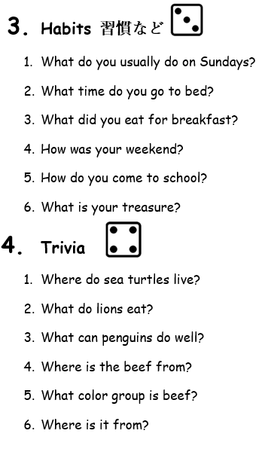
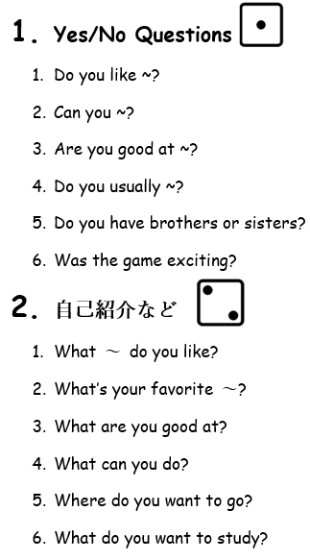
Roll Again
もう一回ふる
Option
選択自由

Dice Roll Small Talk Warm-up
Questions and Answers
Print Page front and back
(Pages Below)

