NAME:
ANIMALS

A | B | C

D | E | F

G | H | I

J | K | L

M | N | O

P | Q | R

S | T | U
V | W | X
Y | Z
NAME:
ANIMALS

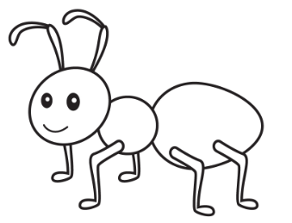
ANT | BEAR | CAT

 | 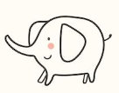
DOG | ELEPHANT | FISH

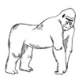 | 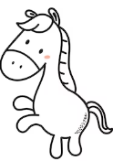 | 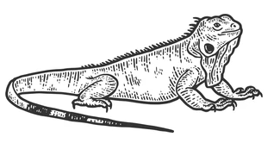
GORILLA | HORSE | IGUANA

 | 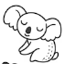 | 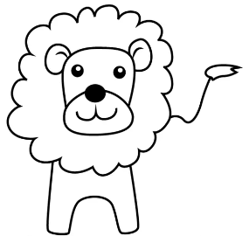
JELLYFISH | KOALA | LION

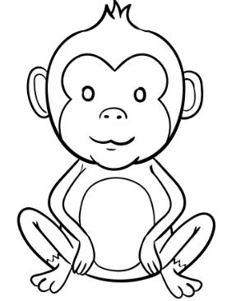
MONKEY | NO | OCTOPUS

 | 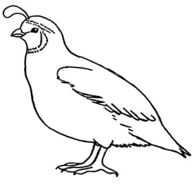 | 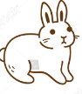
PENGUIN | QUAIL=ウズラ | RABBIT

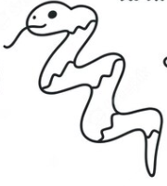 | 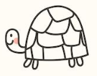 | 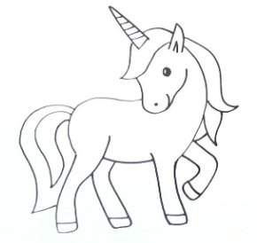
SNAKE | TURTLE | UNICORN
 | 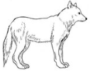 | 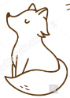
VAMPIRE | WOLF | FOX
 | 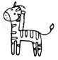
YOYO FISH | ZEBRA
NAME:
ANIMALS

ANT | BEAR | CAT

DOG | ELEPHANT | FISH

GORILLA | HORSE | IGUANA

JELLYFISH | KOALA | LION

MONKEY | NO | OCTOPUS

PENGUIN | QUAIL =ウズラ | RABBIT

SNAKE | TURTLE | UNICORN
VAMPIRE | WOLF | FOX
YOYO FISH | ZEBRA
NAME:
ANIMALS

ant | bear | cat

dog | elephant | fish

gorilla | horse | iguana

jellyfish | koala | lion

monkey | nothing | octopus

penguin | quail=ウズラ | rabbit

snake | turtle | unicorn
vampire | wolf | fox
yoyo fish | zebra
NAME:
ANIMALS

ANT | BEAR | CAT

DOG | ELEPHANT | FISH

GORILLA | HORSE | IGUANA

JELLYFISH | KOALA | LION

MONKEY | NO | OCTOPUS

PENGUIN | QUAIL =ウズラ | RABBIT

SNAKE | TURTLE | UNICORN
VAMPIRE | WOLF | FOX
YOYO FISH | ZEBRA

