New Year’s Traditions
Text

Japan has a unique New Year’s tradition. I think that the New Year is the most important holiday for many Japanese people. On New Year’s Eve, it is common to eat toshikoshi soba and from the New year, osechi is eaten. You can also experience hatsumode and get an omikuji.

But how about other countries? They must have some traditions too, right?

In Spain, with 12 seconds left till the new year, they eat 12 grapes. They think that this will bring in luck! Can you eat 12 grapes in 12 seconds? If you do not, it is bad luck!!

Many countries also welcome the new year with fireworks. In Sydney, Australia, you can see fireworks from the Sydney Harbor Bridge. In London, in the UK, you can enjoy watching beautiful fireworks from the River Thames. It is an exciting way to celebrate the new year!

We know about Christmas trees, but have you ever heard of a New Year Tree? In Russia, it is a tradition to decorate a New Year Tree. This is to continue the holiday cheer and spirit. Recently, it is more eco-friendly to redecorate their Christmas tree.

And last in Brazil, they believe that the number seven is lucky. On New Year’s Eve, we should eat some foods that will give us good luck. So, it is recommended to eat 7 pomegranate seeds for money and 7 grapes for a healthy life.

As you can see, there are so many traditions celebrated around the world. The most important thing we can do, is to make a new year promise. Let’s promise to make 2021 the best year ever!

Thank you for listening.

New Year’s Traditions

Step 1: Dictation
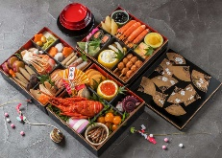
Japan has a unique New Year’s tradition. I think that the New Year is the
①( ) ( ) ( ) for many Japanese people. On New Year’s Eve, it is common to eat toshikoshi soba and from the New year, osechi is eaten. You ②( ) ( ) ( ) hatsumode and get an omikuji.

But how about other countries? They must have some traditions too, right?

In Spain, with 12 seconds left till the new year, they eat 12 grapes. They think that this will bring in luck*! ③( ) ( ) ( ) 12 grapes in 12 seconds? If you do not, it is bad luck!!

Many countries also welcome the new year with fireworks*. In Sydney, Australia, you can see fireworks from the Sydney Harbor Bridge. In London, in the UK, you can enjoy ④( ) ( ) ( ) from the River Thames. It is an exciting way to celebrate* the new year!

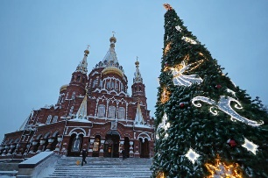
We know about Christmas trees, but ⑤( ) ( ) ( ) heard of a New Year Tree? In Russia, it is a tradition to decorate a New Year Tree. This is to continue the holiday cheer. Recently, it is more eco-friendly* to redecorate their Christmas tree.

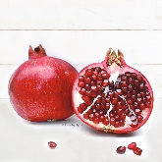
And last in Brazil, they believe that the number seven is lucky. On New Year’s Eve, we ⑥( ) ( ) ( ) foods that will give us good luck. So, it is recommended to eat 7 pomegranate seeds* for money and 7 grapes for a healthy life.

As you can see, there are so many traditions celebrated around the world. The most important thing we can do, is ⑦ ( ) ( ) ( ) ( ) ( ) promise. Let’s promise to make 2021 the best year ever!
Thank you for listening.

*businesses 営業 *luck 運が良い *fireworks 花火 *celebrate 祝う *eco-friendly 環境に良い *pomegranate seeds ザクロも種

Review of New Year’s traditions!

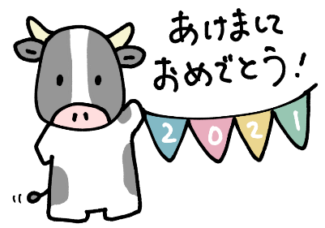
Step 2: Answer the questions 理解Check!

- Which country eats toshikoshi soba on New Year’s Eve?
________________________________________________.
- Which country eats 12 grapes for good luck?
________________________________________________.
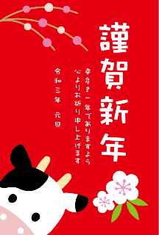
- Which two countries watch fireworks?
________________________________________________.
- What do people in Russia have for the New Year?
________________________________________________.
- For money, what food should I eat in Brazil?
________________________________________________.

Step 3: Write about your New Year’s. (3文) ONLY ENGLISH
__________________________________________________________________________________________________________________________________________________________________________________________________________________________________________________________________________________________________________________________________________________________________________________

Last Step: Ask your partner these questions.

Question | My Answer | Partner’s Answer
- Did you go to hatsumode? | (Yes, I did. / No, I didn’t)
- Did you watch kohaku?
- What osechi do you like eating? | I like…
- What Japanese New Year tradition do you like?
- What is your New Year promise? | My promise is to…

