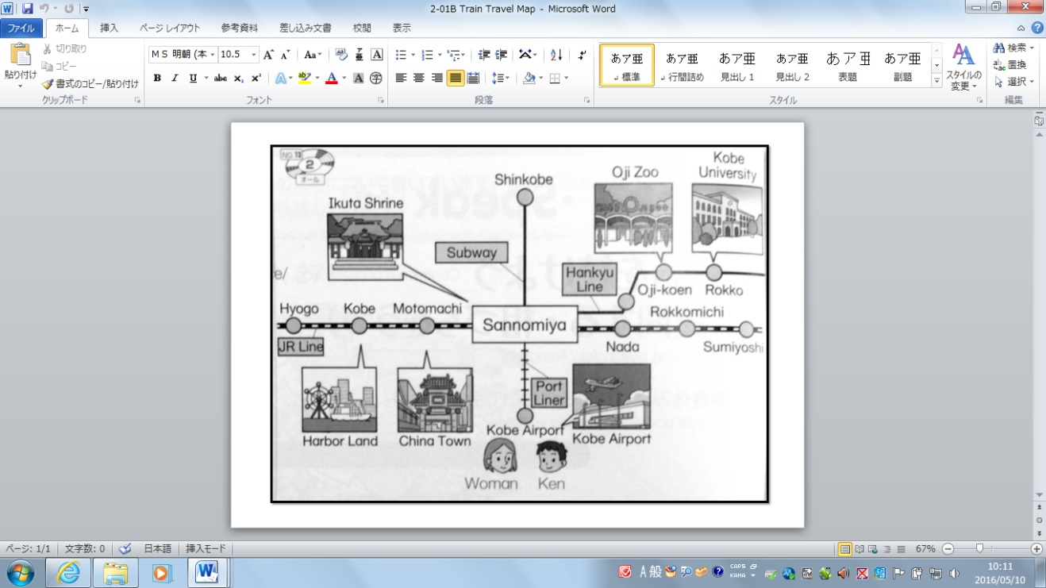

**Travel**

**Osaka**

**Name: ___________**

Yes, Can I help you?

Excuse me.

Take the Port Liner to Sannomiya Station.

Change trains to JR Line.

Then get off at Sumiyoshi Station.

How can I get to Universal Studios?

Sumiyoshi Station. I see. Thank you.

Take care. Have a nice trip.

1. __________________________________________

__________________________________________

__________________________________________

2. ___________________________________________

___________________________________________

___________________________________________

1. ___________________________________________

___________________________________________

___________________________________________

8. __________________________________________

__________________________________________

__________________________________________

7. __________________________________________

__________________________________________

__________________________________________

1. __________________________________________

__________________________________________

__________________________________________

1. __________________________________________

__________________________________________

__________________________________________

1. __________________________________________

__________________________________________

__________________________________________

