English | Japanese
Valentine’s Day
Boyfriend
Girlfriend
Stuffed Animal | 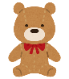
Jewelry | 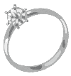
Valentine’s Card | 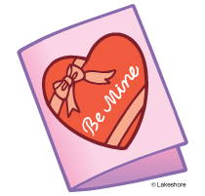
Date
Cupid | 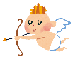
Arrow | 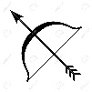
Poem
Rhyme
Rose
Violet

Put them in order

_________ I love you
_________ I kind of like you
_________ I hate you
_________ I am in love with you
_________ I don’t like you
_________ I like you

