Phone Call Relay!

: Hello this is ___________.  Is ___________in?  :( Choose from PART 1 Questions)  : (Choose from PART 3 Reactions) | : Speaking! What’s up __________?  - I think you have the wrong number!  - He/ She is out.  : ( Choose from PART 2 Answers)

Part 1: Questions

Do you want to go to (ばしょ) with me? | Could I use your (なに) tomorrow? | Do we have to come to school tomorrow? | When is (イベント) ?
Who are you going to  （ばしょ） with? | Do you have to (イベントをスケジュールする) today? | Could I leave a message? | We are going to play  ______. Could you join us?
Part 2: Answer  - Sorry, I can’t come. Maybe next time.  - Sure! Let’s go together.  - Ok, see you there  - Sorry, I can’t.  - Yes, you can use it! / No, you can’t use it. Sorry!  - Yes! We have to! / No, we don’t have to.  - Sure! What’s your message?  - I’m going with ______. | 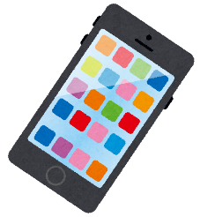  Part 3: Reactions  - Oh I’m sorry! Goodbye.  - Ok, bye.  - Ok. I’ll call back later.  - Great! See you soon.  - I see. Goodbye.  - Thanks! See you tomorrow!

