

Emperor`s

Birthday

Valentine`s

Day



Groundhog Day

Winter Olympics

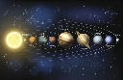

Pluto`s

Discovery

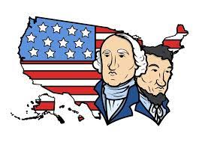

President`s Day

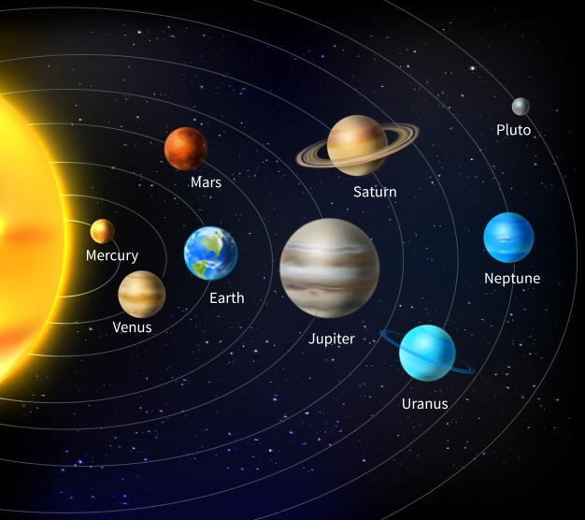

On February 4 the Winter Olympics will start in Beijing!

There will be skiing, ice hockey, curling, and more.

On February 18, 2030 Pluto was by Clyde Tombaugh and William Pickering.

It was the smallest in the solar system.

It is only 1/3 the size of the moon!



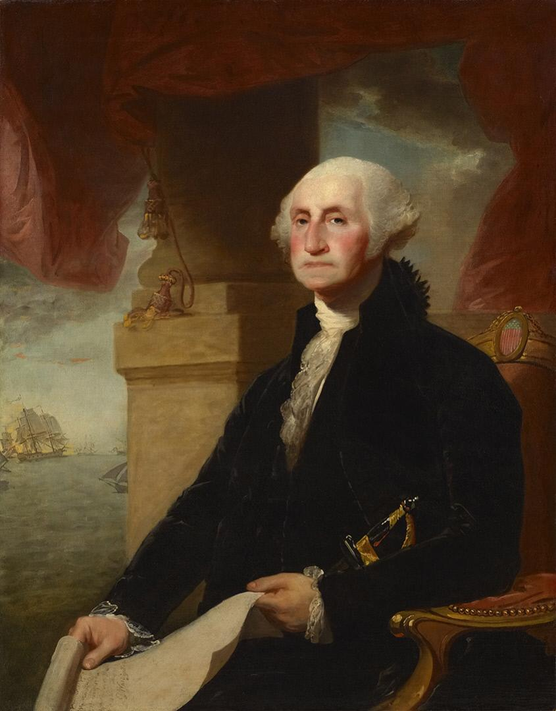

President`s Day

There are 46 American . Do you know who the first president was?

It was George Washington! He was president from 1789 to 1797. He did many things. He helped win America`s .



President`s Day is his birthday.

In schools children learn about him.

Some people eat cherry pies.

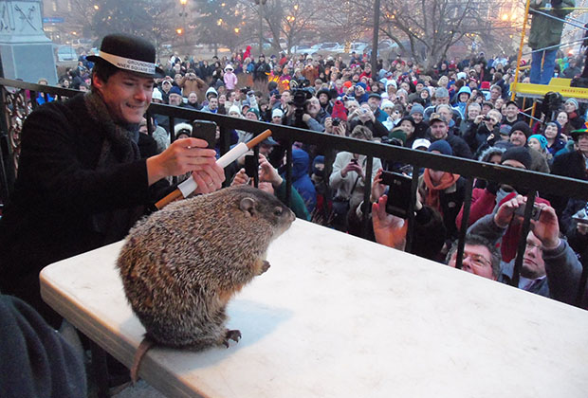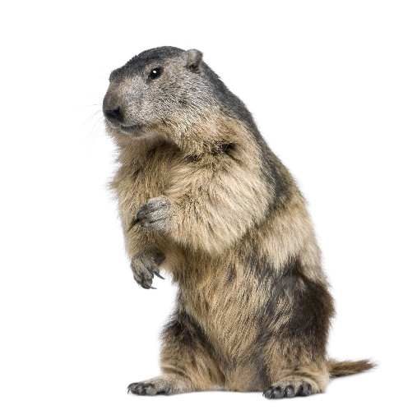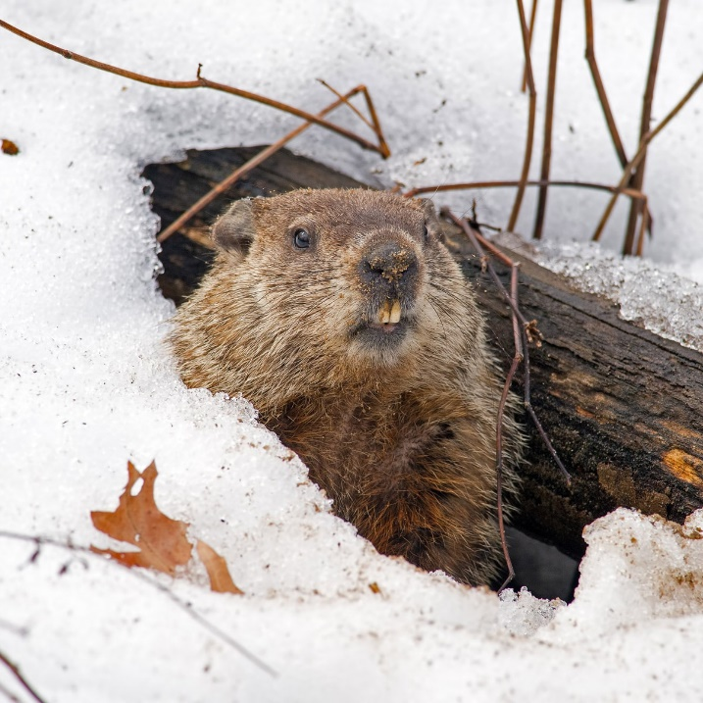

Groundhogs are small animals that live in North America.

They usually sleep all winter, like bears.

If the groundhog wakes up on February 2, winter will end soon.

But if the groundhog sleeps, winter will be long.