Name: ____________ Class: ____ Number: ____ Date: __/___
FILL IN THE BLANKS
- _______ was in the _______. He _____ __________. He was ___________.
- _____ and ______ were in the _______. They _____. They ____ ______.
- ________ ____ at the ______. He ___ ______. It ____ ________.
PICTURE STORIES
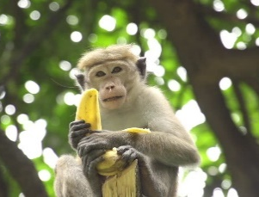 | It was in the forest.  It ate a banana.  It was delicious. | 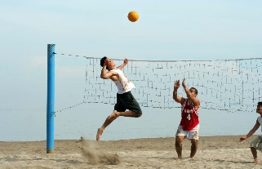 | They were at the beach.  They played volleyball.  They were happy.

____________________________________________________
____________________________________________________
____________________________________________________

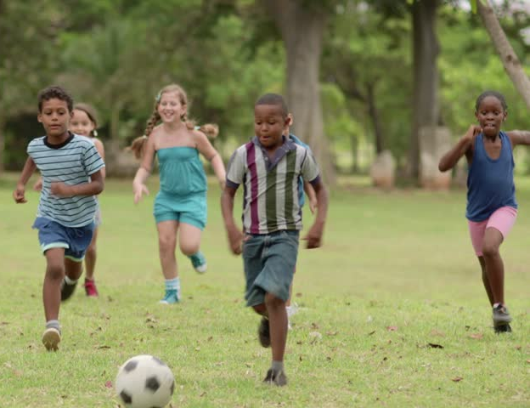
____________________________________________________
____________________________________________________
____________________________________________________

____________________________________________________
____________________________________________________
____________________________________________________

____________________________________________________
____________________________________________________
____________________________________________________
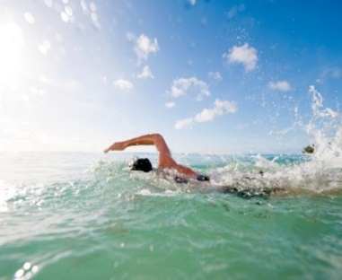
____________________________________________________
____________________________________________________
____________________________________________________
____________________________________________________
____________________________________________________
____________________________________________________

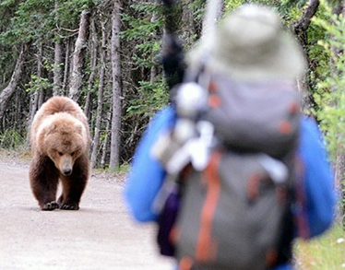
____________________________________________________
____________________________________________________
____________________________________________________

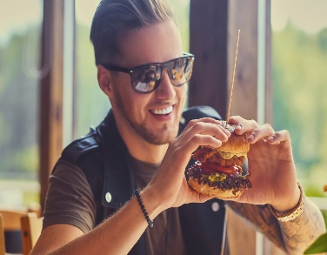
____________________________________________________
____________________________________________________
____________________________________________________

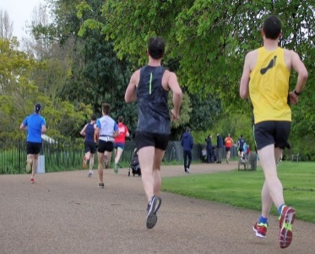
____________________________________________________
____________________________________________________
____________________________________________________
ABOUT YOU

____________________________________________________
____________________________________________________
____________________________________________________

