The Gomi (Trash) Game
Instructions:
- Student organization:
４ students are the trash collectors
Remainder off the students are the trash dumpers
- Supplies:
- Trash vocab sheet (x3 copies) (Pg. 4)
- Scripts for `trash collectors` and `trash depositors`
- Four trash bins (small boxes) with labels (p. 6)
- Timer (Optional) for thinking time and timing of overall activity (latter could be stopwatch)
- Preparation:
1. Print three copies of the vocab list and cut out each rectangle. Give each `trash dumper` six vocab items randomly.
- 2. Print out trash bin labels and affix to boxes. Assign one student to each box (4 total)
- 3. Provide every student with the Activity Sheet so that they can record the information.
- 4. Provide each trash collector with the checklist sheet so they can check if the trash type is accepted before saying yes or no.

Game Learning Intentions：
- Students will develop fluency in using the phrase `do you accept.`
- Students will practice new and existing and new vocabulary.
- Students will practice ethical decision making in regard to be a good environmental citizen
Game Rules:
- Students examine the trash vocab they have been given. They have one minute to read and think about them (still in their seats).
- Students must place the correct Trash Item (the vocab slip) in the correct bin. They must record the Trash Item and the correct bin.
- When depositing their `trash` the students must use the dialogue outlined in the dialogue sheet.
- The first three students that get rid of all their trash (in the correct `bins`) can get a prize! If they think they`re finished, they can check their sheet with the teacher.
- At the end of the game, fast finishing students should have no vocab word slips left.
Notes:
- This vocab list is for a strong class. For weaker classes you could reduce the vocab list. You could also give out fewer than six vocab slips. Alternatively, you could even substitute in your own words.
- For some words that are trickier, you could write the definition on the board
- For smaller class sizes, consider reducing the number of bins to three, but no fewer.
Activity: Trash and Rubbish! Name:____________ Date:______
Dialogue:
Person A: Excuse me, I have some trash.
Person B: Very good. What trash do you have?
Person A: I have a _________________. Do you accept ________________?
Person B: Yes I do/No I don`t. Please give it to me.
Person A: Thank you/sorry.

Recording Sheet:
Number | Trash Item | Bin and bin color
E.g. | Cola Bottle | PET Bottle, yellow
1
2
3
4
5
6

Trash item list for `Trash Dumpers`: (copy and print 3x)
Fish bones
Pepsi can | Grass
Boss coffee can | Wastepaper
Chopsticks | Cardboard boxes
Plastic coffee bottle (e.g., The Latte) | Candy wrappers
Raked Leaves | Shopping bags (plastic)
Spam tin (luncheon meat) | Old envelopes
Newspaper | Plastic Wrap
Cereal Box | Plastic lid
Plastic Bento | Milk Box
100+ Can | Tea Bags
Diapers | Drinking glass
Foam Packing | Knife
Kitchen sponge | Sticks
Chopsticks | Pepsi can
Newspaper | Plastic Wrap
Spam tin (luncheon mean) | Sticks

Reference Table
Household Waste | Green Waste | Recyclable (plastic and paper) | Cans and glass
Fish Bones | Raked Leaves | Plastic coffee bottle | Pepsi Can
Chopsticks | Grass | Newspaper | Boss Coffee Can
Milk Box | Tea bags | Cereal box | Spam Tin
Diapers | Sticks | Plastic Bento | 100+ Can
Kitchen sponge |  | Plastic Wrap | Knife
 |  | Wastepaper | Drinking glass
 |  | Shopping bags (plastic)
 |  | Old envelopes
 |  | Plastic Lid
 |  | Candy wrappers

Labels for Trash Collectors
Hi! My name is________________________. I accept Green Waste. | 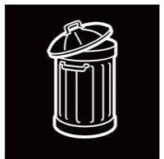  Hi! My name is _____________________. I accept Household Waste.
Hi! My name is: _______________________. I accept Plastic Waste. | Hi! My name is: _________________.  I accept PET Bottles.  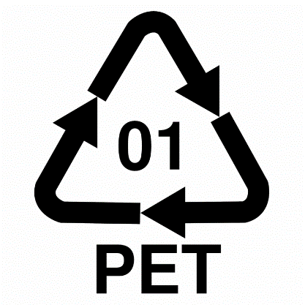
Hi! My name is________________________. I accept metal, cans, and glass.
