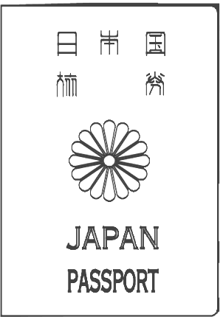







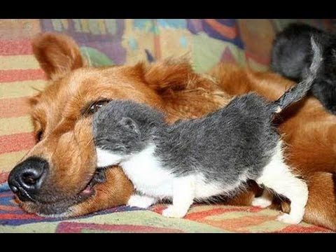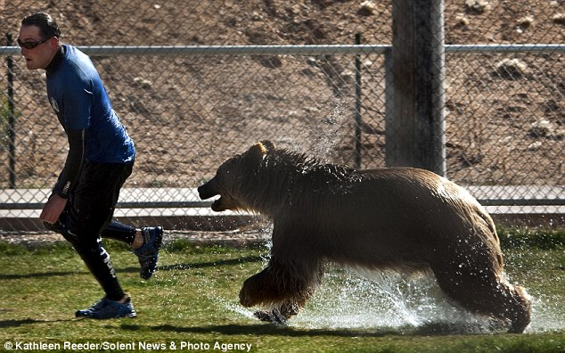

**~ hi-five with a teacher**

**I want you to smile!**

**I want you to run!**

**I want to go to America.**

**I want to ~**

**KEY WORDS**

clap

roll again

laugh

hi-five

blink

shake hands

introduce yourself

We want you to ~

**GOAL**

1st: ___________

2nd: __________

3rd: __________

4th: __________

5th: __________

6th: __________

**~ go to the UK**

**~ go back 5 spaces**

**~ be a monkey**

**~ ask us a question**

**~ draw a monster on the board**

**~ go back 4 spaces**

**~jump 5 times**

**~ go to Korea**

**~ be a cat**

**~ sing the ABC song**

**~ open to page 8 and read**

**~ introduce yourself to us**

**~ shake hands with a teacher**

**~ say hello to a different group**

**~ introduce yourself to a teacher**

**~ draw a star on the board**

**~ go back 4 spaces**

**~ go to Australia**

**~ shake our hands**

**~ blink 5 times**

**~ stand up and sit down twice**

**~ go back 4 spaces**

**~ go to India**

**~ hi-five with us**

**~play jankan with the teacher**

**~ draw an animal on the board**

**~ ask the teacher a question**

**~ count to 20**

**~ go to Canada**

**~ laugh**

**~ open the window**

**~ roll again**

**~ be a dog**

**~ draw your face on the board**

**~ roll again**

**~ open the door**

**~ say hello to a teacher**

**~ clap your hands 5 times**

**~ go to America**

**~ write your name on the board**

**~ sing happy birthday**

**~jump 3 times**

**START**