Show ALT a red pen. | Tell ALT the time. | Give ALT a ball.
Show ALT a textbook. | Tell ALT the date. | Give ALT a fan.
Show a tablet to ALT. | 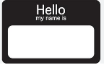  Tell your name to ALT. | Give a high five to ALT.
Show your left hand to ALT. | Tell the answer to ALT.  (1+2 =______) | Give a keychain to ALT.
Show JTE your left hand. | Tell JTE the answer.  (1+2 =______) | Give JTE a keychain.
Show JTE a tablet. | Tell JTE your name. | Give JTE a high five.
Show a red pen to JTE. | Tell the time to JTE. | Give a ball to JTE.
Show a textbook to JTE. | Tell the date to JTE. | Give a fan to JTE.
Show ALT 5 jumping jacks. | Tell ALT your city’s name. | Give ALT a box.  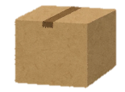
Show ALT a pencil. | Tell ALT your favorite food. | Give ALT a keychain.
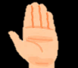  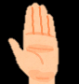  Show both hands to ALT. | Tell the time to ALT. | Give a post-it to ALT.
Show a paper to ALT. | Tell the answer to ALT.  (3+4 =______) | Give a bag to ALT.  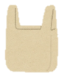
Show JTE a paper. | Tell JTE the answer.  (3+4 =______) | Give JTE a bag.
Show JTE both hands. | Tell JTE the time. | Give JTE a post-it.
Show a pencil to JTE. | Tell your favorite food to JTE. | Give a keychain to JTE.
Show 5 jumping jacks to JTE. | Tell your city’s name to JTE. | Give a box to JTE.
Show ALT an eraser. | Tell ALT your school’s name. | Give ALT a post-it.
Show ALT a slipper. | Tell ALT your favorite color. | Give ALT dice.
Show your right hand to ALT. | Tell the time to ALT. | Give a pen to ALT.
Show a pencil case to ALT. | Tell the answer to ALT.  (8-3 =______) | Give a greeting to ALT.
Show JTE a pencil case. | Tell JTE the answer.  (8-3 =______) | Give JTE a greeting.
Show JTE your right hand. | Tell JTE the time. | Give JTE a pen.
Show a slipper to JTE. | Tell your favorite color to JTE. | Give dice to JTE.
Show an eraser to JTE. | Tell your school’s name to JTE. | Give a post-it to JTE.

