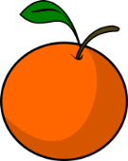
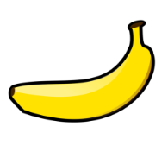
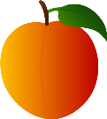
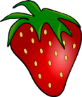
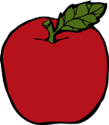
Fun Fruits
Name: ____________________ Number: _____ Class: _____
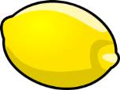
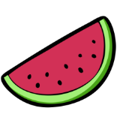

例: This is an __________. Is that a ____________?
- ______________________________________________
______________________________________________
- ______________________________________________
______________________________________________
- ______________________________________________
______________________________________________
- ______________________________________________
______________________________________________
- ______________________________________________
______________________________________________
- ______________________________________________
______________________________________________
- ______________________________________________
______________________________________________
- ______________________________________________
- ______________________________________________
- ____________________________________________
- ____________________________________________
- ____________________________________________

