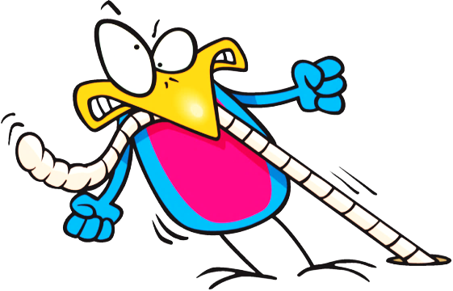

Name: ______________

…gets the worm.

The early bird…

#1

I get up at _________.

What time do you get up?

Name: ____________

Time: ____:____ ____

Name: ____________

Time: ____:____ ____

Name: ____________

Time: ____:____ ____

______________ is the early bird.

#2

What time do you ___________?

I ____________ at_____.

Name: ____________

Time: ____:____ ____

______________ is the early bird.

Name: ____________

Time: ____:____ ____

Name: ____________

Time: ____:____ ____

#3

What time do you __________?

I ____________at_______.

Name: ____________

Time: ____:____ ____

_______________ is the early bird.

Name: ____________

Time: ____:____ ____

Name: ____________

Time: ____:____ ____

#4

What time do you _________?

Name: ____________

Time: ____:____ ____

Name: ____________

Time: ____:____ ____

_________________ is the late bird.

Name: ____________

Time: ____:____ ____

Name: ____________

Time: ____:____ ____

Name: ____________

Time: ____:____ ____

________________ is the late bird.

Name: ____________

Time: ____:____ ____

I ___________________.

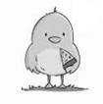

What time do you ___________?

What time do you __________?

I _____________________.

I’m happy. I’m the late bird.

I don’t like worms.

I _____________________.

#6

#5

Name: ____________

Time: ____:____ ____

_________________is the late bird.

Name: ____________

Time: ____:____ ____

Name: ____________

Time: ____:____ ____