Mission 1: Unscramble the words.
例： lfy → f l y

- lullayb → ｌｕｌｌａｂｙ
- jnirdeu → ｉｎｊｕｒｅｄ
- cedsiino → ｄｅｃｉｓｉｏｎ
- strdeyo → ｄｅｓｔｒｏｙ
- grenda → ｄａｎｇｅｒ

Mission 2: Draw pictures to explain the words.
Answers will vary.

logging | accident | driving
report | cry | shade

Mission 3: Unscramble the sentences.

- Emi / to / get up / early / it's / easy / for
It's easy for Emi to get up early.
- i / him / want / take out / to / the garbage
I want him to take out the garbage.
- fun / it's / walk / dog / our / to
It's fun to walk our dog.
- you / i / want / to / my / draw / face
I want you to draw my face.
- important / read / to / many books / it's
It's important to read many books.

Mission 4: Fill in the blank. Answers may vary, so some of these are just examples.

1. It is important for everyone to protect the environment.
2. I want people to know this fact.
3. It is interesting for me to learn about animals.
4. Meg wants Kaito to check his English.
5. Mr. Toda wants the students to make a speech.

Mission 5: Two people go to a teacher. Read page 38.
（2人）

Mission 6: Finish the sentences about yourself.
(All answers must be different.)
Example answers:

- It is easy for me to listen to music.
- It is fun for me learn something new.
- It is difficult for me to study math.
- It is tiring for me to play sports.
- It is important for me to work hard.

Mission 7: Go to a teacher. Answer the questions.
3 questions for 1 person. OR 1 question per person in the group.
(add a 4th question if you do that)
- What is fun for you to do?
  - It is fun for me to_______.
- What is difficult for you to do?
  - It is difficult for me to ______.
- What is easy for you to do?
a. It is easy for me to_____.
Mission 8: Use your textbook to fill in the blanks.
↓(HINT: p. 37)
1. Many kinds of animals are in danger of extinction.

2. It is difficult for endangered animals to live in these conditions.

3. It is important for us to learn this.

↓(HINT: p. 40)
4. People tried to help them live safely, but they died one by one.
↓(HINT: p. 42)
5. So, it is important for us to take action now.

6. Let's help the animals survive.

Mission 10: Find these words. ⇄ ⇵ ⤨ ⤪

extinction | survive | environment | safely | electronic
species | road | bomb | dead | devices

Mission 9: Crossword
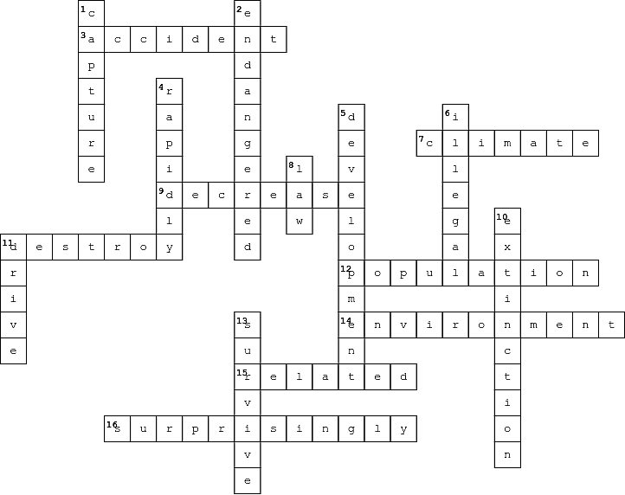

Across  3. 事故  7. 気候  9. 減る  11. …を破壊する  12. 人口  14. 環境  15. 関係させる  16. 驚いたことには |  | Down  1. …を捕まえる  2. 絶滅の危機にさらされている  4. 速く  5. 開発  6. 違法な  8. 法律  10. 絶滅  11. 運転する  13. 生き残る

