Name: ___________ Class: ___ Number: ___ Date: __/___
- What is the longest river in Japan?
_______________________________________________________
_______________________________________________________
- Who has the nicest voice on TV?
_______________________________________________________
_______________________________________________________
- What is the tallest mountain in Japan?
_______________________________________________________
_______________________________________________________
- Who is the cutest character in the world?
_______________________________________________________
_______________________________________________________
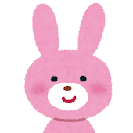
- What is the coldest month of the year?
_______________________________________________________
_______________________________________________________
- What is the hardest day of the week?
_______________________________________________________
_______________________________________________________
- What is the nicest place in your town?
_______________________________________________________
_______________________________________________________

