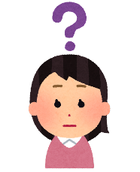
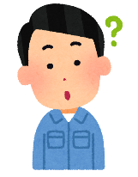
What do you know?
Round 1: Fix The Question!
例) Do you know (longest / what / in Japan / river / is / the) ＿＿＿＿＿＿＿＿＿＿＿＿＿＿＿＿＿＿?
what the longest river in Japan is
Answer: It’s the Shinano River.
- Do you know (Mt Fuji / tall / how / is) ＿＿＿＿＿＿＿＿＿＿＿＿＿＿＿＿＿＿＿＿＿＿＿＿＿＿＿＿?
Answer: It’s 3,776m tall.
- Do you know (the Giants / baseball / play / where) ＿＿＿＿＿＿＿＿＿＿＿＿＿＿＿＿＿＿＿＿?
Answer: At Tokyo Dome.
- Do you know (countries / which / four / dollars / use) ＿＿＿＿＿＿＿＿＿＿＿＿＿＿＿＿＿＿＿＿?
Answer: Canada, Australia, America and New Zealand.
- Do you know (smallest / in / country / the world / is) ＿＿＿＿＿＿＿＿＿＿＿＿＿＿＿＿＿＿＿＿?
Answer: It’s the Vatican City.
Round 2: Answer The Question - Using Full Sentences!
例) Do you know how many people live in Miyazaki prefecture?
I know ＿＿＿＿＿＿＿＿＿＿＿＿＿＿＿＿＿＿＿＿＿＿＿ ＿＿＿＿＿＿＿＿＿＿＿＿＿＿＿＿＿＿.
Around one million people.
how many people live in Miyazaki prefecture.
- Do you know who the president of the United States is?
I know ＿＿＿＿＿＿＿＿＿＿＿＿＿＿＿＿＿＿＿＿＿＿＿ ＿＿＿＿＿＿＿＿＿＿＿＿＿＿＿＿＿＿.
- Do you know when we can see cherry blossoms?
I know ＿＿＿＿＿＿＿＿＿＿＿＿＿＿＿＿＿＿＿＿＿＿＿ ＿＿＿＿＿＿＿＿＿＿＿＿＿＿＿＿＿＿.
- Do you know what food starts with a P and ends with an A?
I know ＿＿＿＿＿＿＿＿＿＿＿＿＿＿＿＿＿＿＿＿＿＿＿ ＿＿＿＿＿＿＿＿＿＿＿＿＿＿＿＿＿＿.

