Mission 1: Unscramble the words.
例： lfy → f l y

- lullayb → __ __ __ __ __ __ __
- jnirdeu → __ __ __ __ __ __ __
- cedsiino → __ __ __ __ __ __ __ __
- strdeyo → __ __ __ __ __ __ __
- grenda → __ __ __ __ __ __

Mission 2: Draw pictures to explain the words.

logging | accident | driving
report | cry | shade

Mission 3: Unscramble the sentences.

- Emi / to / get up / early / it's / easy / for
________________________________________________________
- i / him / want / take out / to / the garbage
________________________________________________________
- fun / it's / walk / dog / our / to
________________________________________________________
- you / i / want / to / my / draw / face
________________________________________________________
- important / read / to / many books / it's
________________________________________________________

Mission 4: Fill in the blank.
1. It is ______________ for _____________ to protect the environment.
2. I _________ people to know this fact.
3. It is interesting _______ me _______ learn about animals.
4. Meg ___________ Kaito ______ check his English.
5. Mr. Toda wants the students ______ ___________ a speech.

Mission 5: Two people go to a teacher. Read page 38.
（2人）

Mission 6: Finish the sentences about yourself.
(All answers must be different.)

- It is easy for me ________________________________.
- It is fun for me _________________________________.
- It is difficult for me ______________________________.
- It is tiring for me _________________________________.
- It is important for me _____________________________.

Mission 7: Go to a teacher. Answer the questions.

Mission 8: Use your textbook to fill in the blanks.
↓(HINT: p. 37)
1. Many kinds of animals are in danger of ____________.

2. It is ___________ for _____________ animals ____ ___________ in these conditions.

3. It is ______________ _______ us to _______________ this.

↓(HINT: p. 40)
4. People tried _____ __________ them _________safely, but they died one by one.
↓(HINT: p. 42)
5. So, it _____ _______________ ______ us to _______ action now.

6. Let's ________ ______ _____________ survive.

Mission 10: Find these words. ⇄ ⇵ ⤨ ⤪

extinction | survive | environment | safely | electronic
species | road | bomb | dead | devices

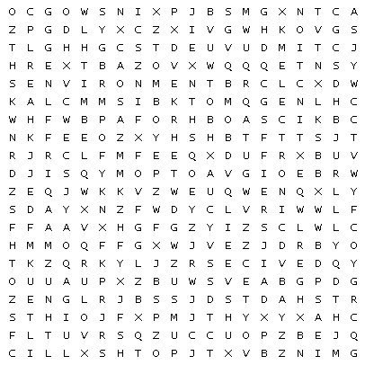

Mission 9: Crossword
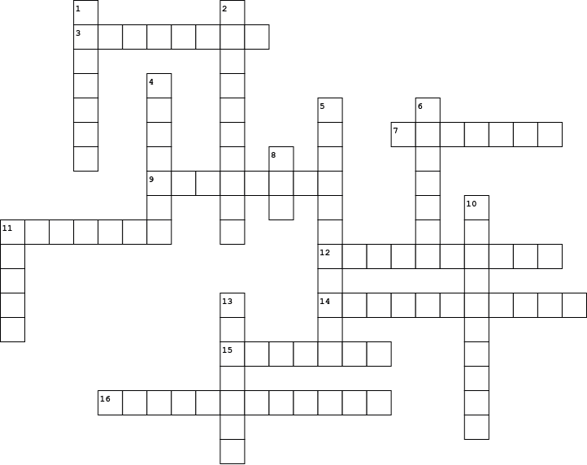

Across  3. 事故  7. 気候  9. 減る  11. …を破壊する  12. 人口  14. 環境  15. 関係させる  16. 驚いたことには |  | Down  1. …を捕まえる  2. 絶滅の危機にさらされている  4. 速く  5. 開発  6. 違法な  8. 法律  10. 絶滅  11. 運転する  13. 生き残る

