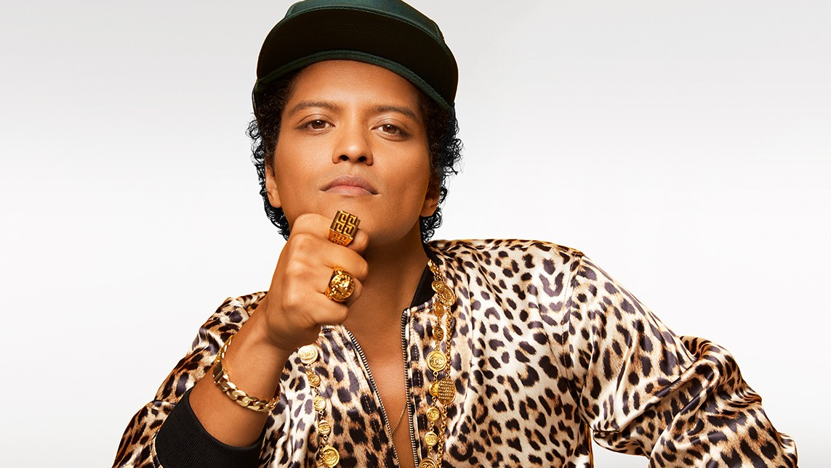

Bruno Mars
Genre: Pop
Best songs to learn English: The Lazy Song, Happy.

Taylor Swift
Genre: Pop
Easy songs to learn English: The Best Day, Ronan.

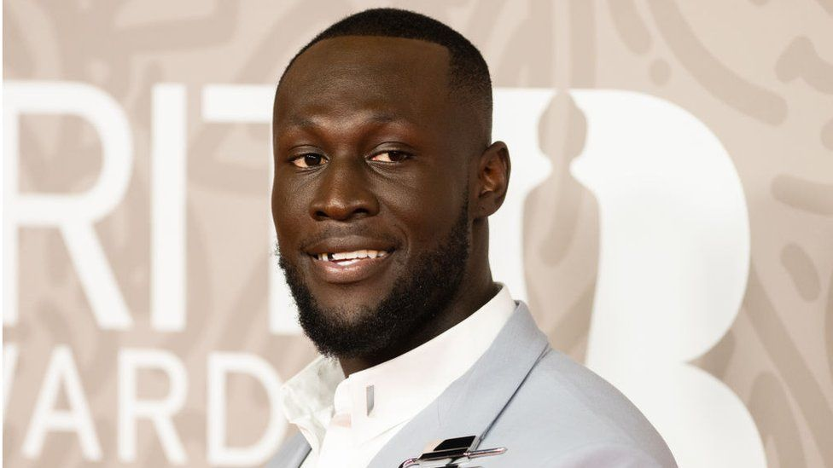

Stormzy
Genre: Rap
Stormzy is the UK most famous rapper. His songs words are a little difficult but his songs are very famous and fun to listen to.

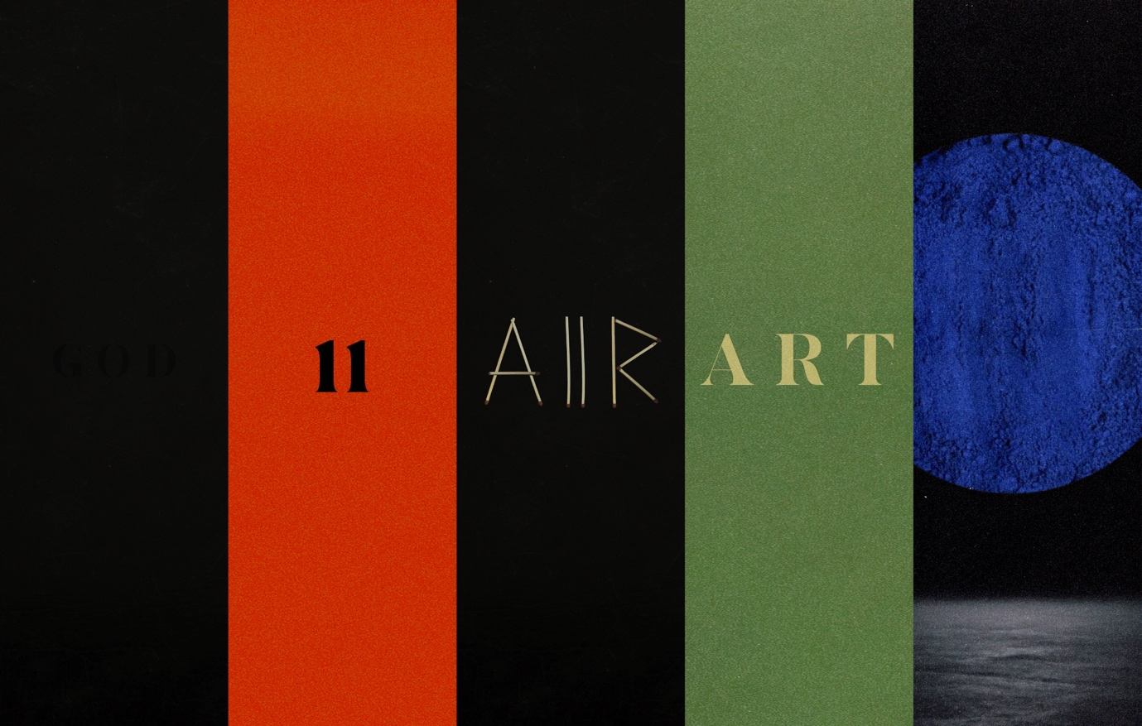
SAULT
Genre: Hip-hop, Jazz, Soul
SAULT is also a UK band. Nobosy knows the band members names and faces. Their music has some lyrics that a repeated, so it can be easy to remember words.

