Your Name: _______________________________________ Student Number: 2-____( )
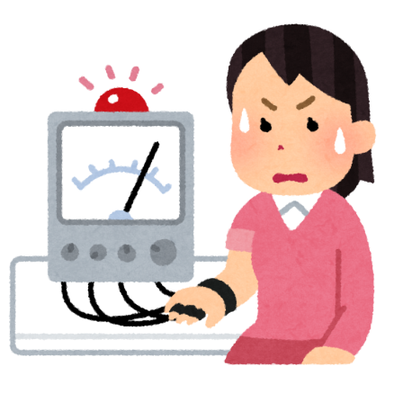
Partner Name: ____________________________________ Student Number: 2-____( )

2 Truths and a Lie

<Instructions>
- Write 2 true statements and 1 false statement
- Read your statements to your partner in a random order
- Let your partner guess which statement is a lie
Truth 1 | -------------------------------------------------------------------------------------------------------------  -------------------------------------------------------------------------------------------------------------  -------------------------------------------------------------------------------------------------------------
Truth 2 | -------------------------------------------------------------------------------------------------------------  -------------------------------------------------------------------------------------------------------------  -------------------------------------------------------------------------------------------------------------
Lie | -------------------------------------------------------------------------------------------------------------  -------------------------------------------------------------------------------------------------------------  -------------------------------------------------------------------------------------------------------------

Bonus Time
Did you guess your partner’s lie?
What was your partner’s lie?

