Pink Circle Free Stock Photo - Public Domain PicturesOrange Circle Free Stock Photo - Public Domain Pictures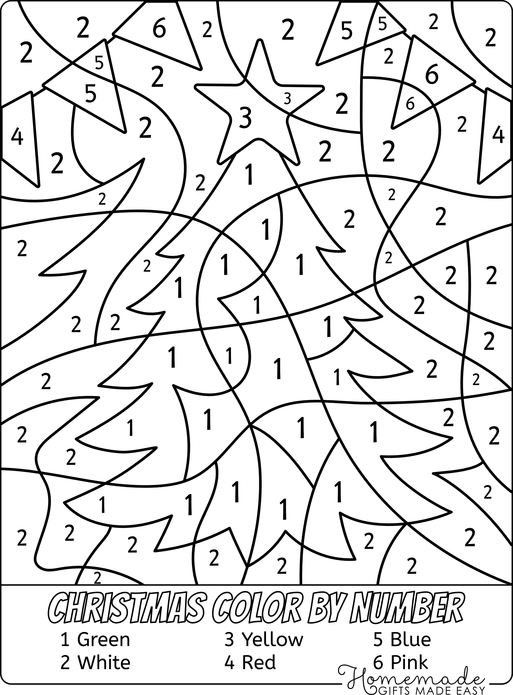

2 Orange