Name ___________________________ Class ____ Number ____



Match the correct sentences and write them on the lines.

Kyoto

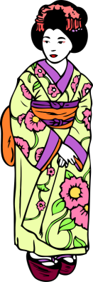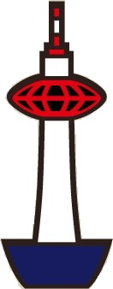

There is ______________________________________________________________

_____________________ Kyoto.

There are _______________________________________________________ Kyoto.

Kyoto is _______________________________________________________________.

You can ________________________________________________________ there.

There is ______________________________________________________________

____________________ Disneyland.

There are __________________________________________________ Disneyland.

Disneyland is __________________________________________________________.

You can ________________________________________________________ there.

Disneyland

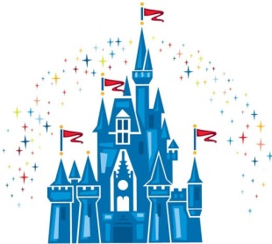

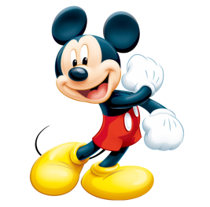

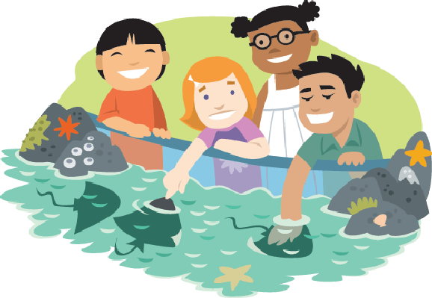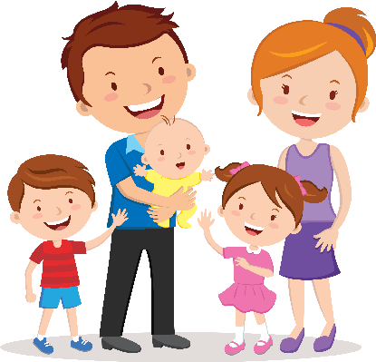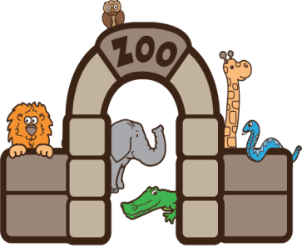

Sunshine Aquarium

*a city in Japan called

*a place in Ueno called

*a place in Tokyo called

*a place in Ikebukuro called

Ueno Zoo

*buy many souvenirs

*ride many attractions

*take a photo with fish

*see an elephant

*many kinds of animals in

*many beautiful places in

*many kinds of fish in

*many rides to enjoy in

*a lot of fun

*in Ueno Park

*near Osaka

*in the Sunshine Building

There is ______________________________________________________________

_____________________ Ueno Zoo.

There are ______________________________________________________ the zoo.

The zoo is _____________________________________________________________.

You can ________________________________________________________ there.

There is ______________________________________________________________

______________________ Sunshine Aquarium.

There are ________________________________________________ the aquarium.

The aquarium is _______________________________________________________.

You can ________________________________________________________ there.